**JAVASCRIPT FUNDAMENTALS**

1. **What is JavaScript?:**

JavaScript is high level, object oriented, multi paradigm programming language.

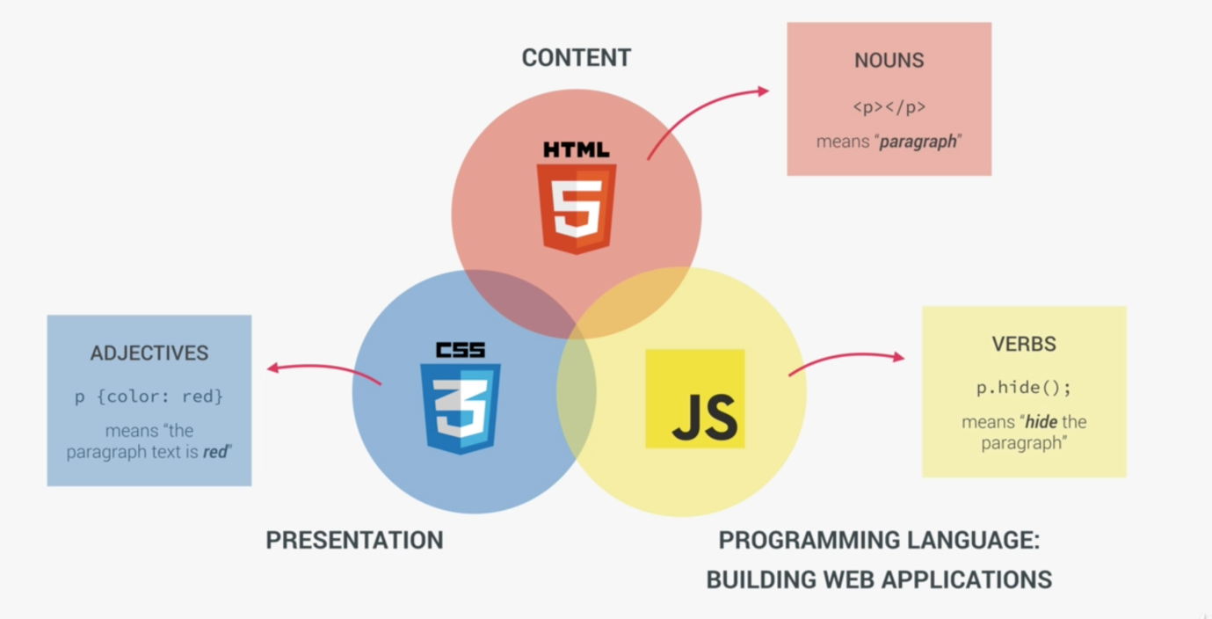

1. **Applications of JavaScript:**

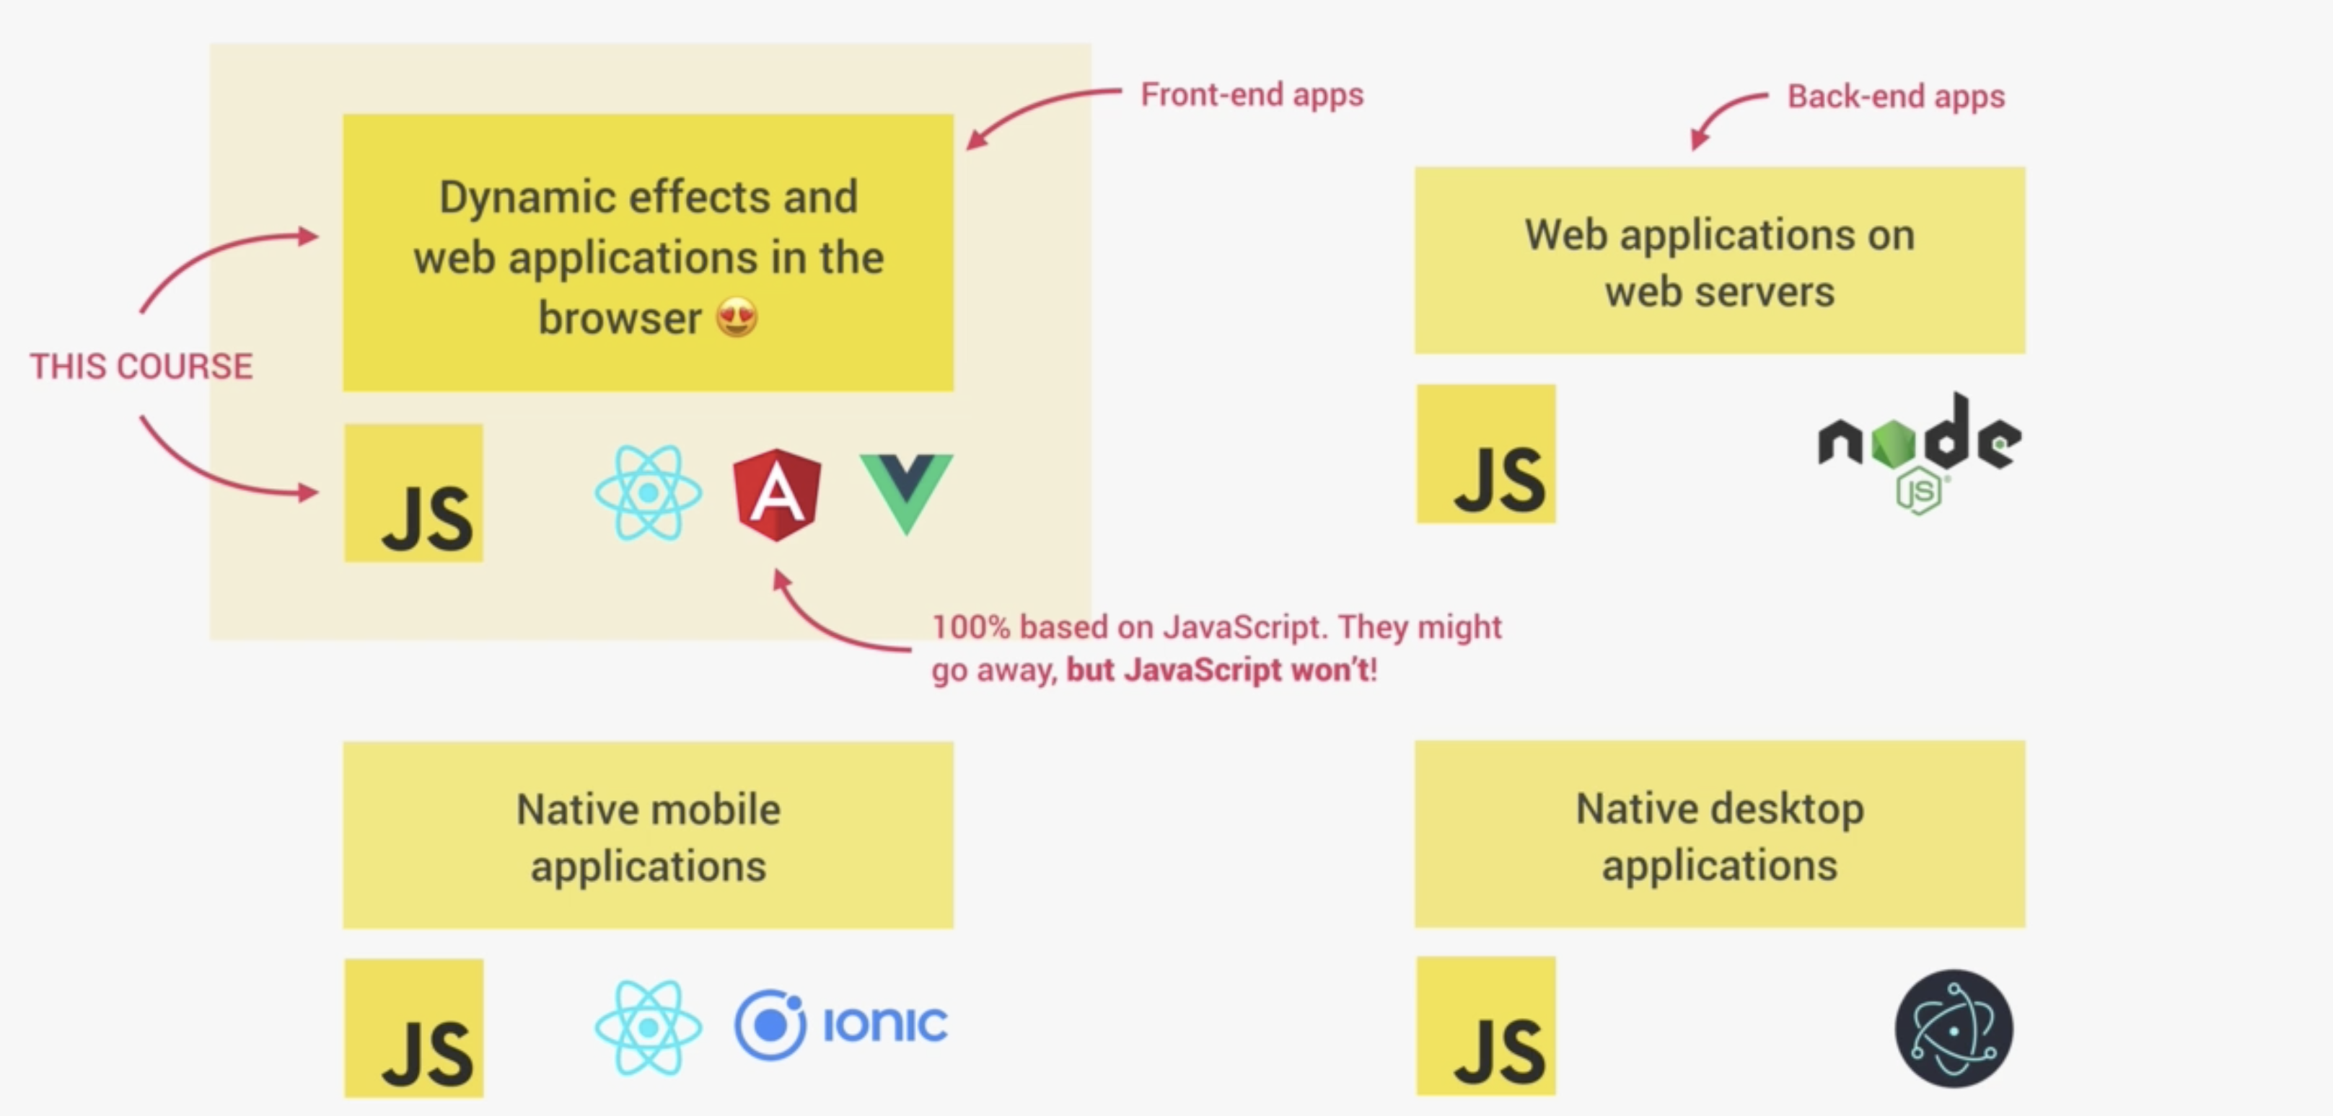

1. **JavaScript Releases:**

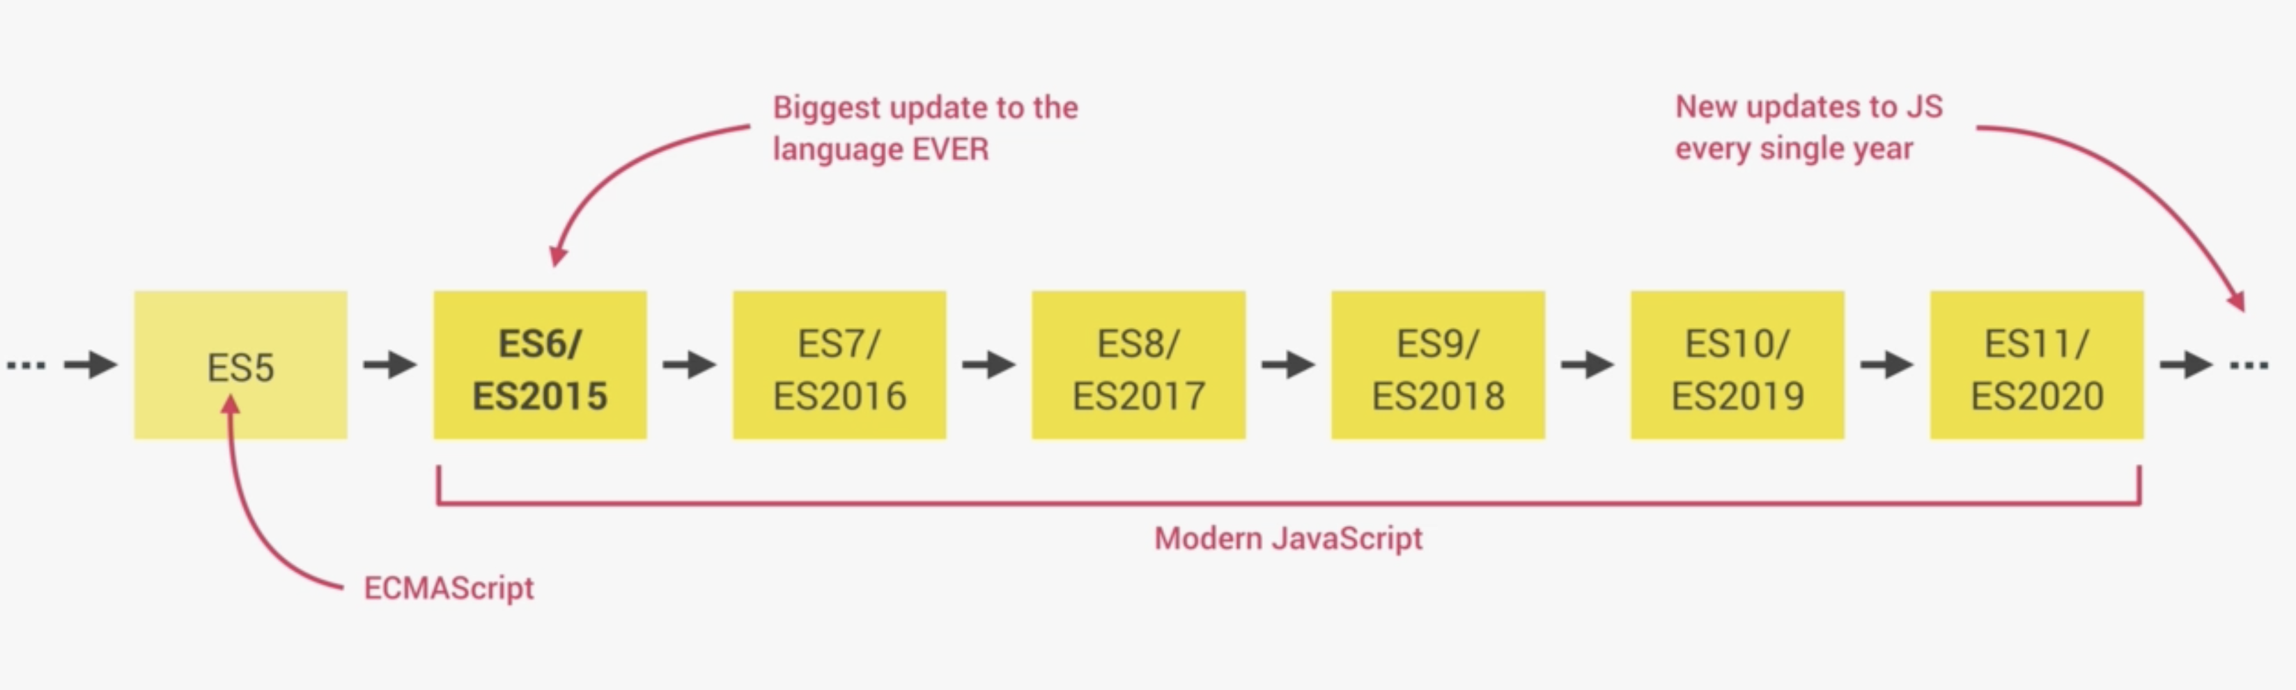

1. **JavaScript Data Types:**

There are six primitive values in JavaScript:

1. Boolean
2. String
3. Number
4. Null
5. Undefined
6. Symbol

All other values are objects (functions, arrays, objects etc)

1. **undefined vs null**

let a;

console.log(a); //undefined

console.log(typeof a) //undefined

let b = null;

console.log(b); null

console.log(typeof b) //object. This is a mistake in JavaScript since its original implementation.

In JavaScript there are only 6 falsy values.

1. false
2. 0(zero)
3. “”(empty string)
4. null
5. undefined
6. NaN(Not a Number)

Any other value in JavaScript are considered truthy.

Main Points:

1. null is an assigned value. It means nothing.
2. undefined typically means a variable has been declared but not defined yet.
3. null and undefined are both falsy values.
4. null and undefined are both primitives. However an error shows that typeof null is object.
5. null !== undefined but null == undefined
6. **Strings and Template Literals**
7. **Using regular strings:**

*let* job = 'Developer';

*let* country = 'India';

*let* company = 'NetApp';

*let* loc = 'Bangalore';

*let* bigString = "I'm" + ' a '+ job + ' at '+ company + ', ' + loc + ', ' + country;

It becomes somewhat difficult to manage spaces and characters this way.

Another case is of multi-line string:

*let* multiLineString = 'This is a \n\multiline \n\string';

1. **Using Template Literals:**

Template literals are string literals allowing embedded expressions. You can use multi-line strings and string interpolation features with them.

Template literals are enclosed by the backtick (` `) character instead of double or single quotes.

*let* bigString = `I'm a ${job} at ${company}, ${loc}, ${country}`;

Much simpler and syntactic sugar!!

*let* multiLineString = `This is a

multiline

string`;

1. **Type Conversion**

/**String to Number conversion. */

const inputYear = ‘1991’;

console.log(Number(inputYear));

/**Number to String conversion. */

const year = 1991;

console.log(String(year));

1. **Type Coercion:**

Automatic type conversion

console.log(‘I am ‘ + 23 + ‘ years old’);

Here JavaScript took care of mismatching types and converted number to string automatically.

Same needs to be done manually in other languages like this:

console.log(‘I am ‘ + String(23) + ‘ years old’);

1. **Equality operators: == and ===**
2. Strict equality operator(===):

18 === ‘18’ // false

1. Loose equality operator(==):

18 == ‘18’ // true

1. **Strict Mode**

Use‘use strict’ at the beginning of the script to activate strict mode.

It enables security and reduces error in code.

1. **Functions**
2. **Function declaration:** Functions can be called before declaring.

function calcAge1(birthYear) {

return 2037 – birthYear;

}

const age1 = calcAge1(1991);

console.log(age1);

1. **Function expression:** Functions cannot be called before declaring.

const calcAge2 = function (birthYear) {

return 2037 – birthYear;

}

const age2 = calcAge2(1991);

console.log(age2);

1. **Arrow functions:** Does not get ‘this’ keyword
2. **Simple functions(direct return)**

**Syntax:**

dataType functionName = single argument => implicit return statement;

**Example:**

const calcAge3 = birthYear => 2037 – birthYear;

const age3 = calcAge3(1991);

console.log(age3);

1. **Somewhat complex functions, needs block of code**

**Syntax:**

datatype functionName = (multiple arguments) => {

//block of code

}

**Example:**

const yearsUntilRetirement = birthYear => {

const age = 2037 – birthyear;

const retirement = 65 – age;

return retirement;

}

const yearsInRetirement = yearsUntilRetirement(1991);

console.log(yearsInRetirement);

1. **Arrays**

const years = new Array(1991, 1992, 1993, 1994);

const months = [‘Jan’, ‘Feb’, ‘Mar’, ‘Apr’];

console.log(months.length);

/**Even though years array has been declared as const, but it can still be changed. Only primitive data types are immutable and array is not a primitive data type. But we cannot change entire years array. */

years[2] = 1995;

console.log(years);

/** Array can contain multiple data types. */

const years = [1991, 1992, ‘1993’, ‘Nineteen ninety four’];

Array is also an object.

**Array Operations:**

1. **push:** Adds an element to the end of an array and returns the length of new array.
2. **unshift:** Adds an element at the beginning of the array and returns the length of new array.
3. **pop:** Remove the element from the end of the array and returns the popped element.
4. **shift**: Remove the element from the beginning of the array and returns the popped element.
5. **indexOf**: Returns the index at which the element is located.
6. **includes**: Returns if the element is present in the array.
7. **Objects**

const person = {

firstName: ‘Deepak’,

lastName: ‘Laxkar’,

age: 2037 – 1991,

job: ‘student’

};

**Accessing object properties:**

1. Dot notation: Exact key name is required

**Syntax**:

Object.keyname;

console.log(person.age);

1. Bracket notation: When key is dynamic expression.

**Syntax**:

Object[expression];

console.log(person[‘age’]);

const propName = ‘Name’;

console.log(person[‘first’ + propName]);

**Adding new property to an object:**

Can use any of the above methods to add a new fields to the object.

person.location = ‘India’;

person[‘gender’] = ‘male’;

**Object Methods:**

Since function is also a type of a value in javascript, we can store a function in the object by assigning it to a key.

const person = {

firstName: ‘Deepak’,

lastName: ‘Laxkar’,

birthYear: 1991,

job: ‘student’,

calcAge: function(birthYear) {

return 2037 – birthYear;

}

};

console.log(person.calcAge(1991));

console.log(person[‘calcAge’(1991)]);

We can also access ‘this’ inside the object.

const person = {

firstName: ‘Deepak’,

lastName: ‘Laxkar’,

birthYear: 1991,

job: ‘student’,

calcAge: function() {

return 2037 – this.birthYear;

/**could have also done person.birthYear. But that would be tied to the object name and not a good design. **/

}

};

If we require to call calcAge() multiple times, and if it is some complex computation then it is wiser to introduce a key in the object and store the computed value in it. Later use the value directly.

const person = {

firstName: ‘Deepak’,

lastName: ‘Laxkar’,

birthYear: 1991,

job: ‘student’,

calcAge: function() {

this.age = 2037 – this.birthYear;

}

};

Now just call it once and use the value in later calls.

person.calcAge(); // Compute the value once

person.age(); // Directly use it afterwards

1. **Debugging**

const person = {

firstName: ‘Deepak’,

lastName: ‘Laxkar’,

birthYear: 1991,

job: ‘student’,

};

console.log(person)

console**.**table(person)// Outputs the information in tabular manner.

console.warn(person);

console.error(person);

We can use breakpoint, by manually adding the breakpoint in the file at the specific location using Google Chrome. But this can also be done in code itself. Just write degugger; in the place where you want the breakpoint.

**HOW JAVASCRIPT WORKS BEHIND THE SCENES**

JavaScript is a **High-Level**, **Prototype-Based Object-Oriented**, **Multi-Paradigm**, **Interpreted or Just-In-Time Compiled**, **Dynamic**, **Single-Threaded**, **Garbage-Collected** programming language with **First-Class functions** and a **Non-Blocking Event Loop Concurrency Model**.

1. High-Level: Human readable language.
2. Prototype-Based Object-Oriented: Everything is object in JavaScript except for the primitive values. Array is an object. We can add an element into array by array.push() method. This is inherited from Array prototype.
3. Multi-Paradigm: A paradigm is an approach and mindset of structuring code, which will direct your coding style and technique.
4. Procedural Programming
5. Object-Oriented Programming
6. Functional Programming
7. Interpreted or JIT:
8. Dynamic: It is Dynamically typed language. No data type definitions. Types becomes known at runtime. Data type of variable is automatically changed.
9. Single-Threaded: JavaScript runs in one single thread, so it can do only one thing at a time.
10. Garbage Collected: We don’t have to clean the memory. Garbage collector automatically does it for us.
11. First-Class functions: Functions are simply treated as variables. We can pass them into other functions and return them from functions.
12. Non-Blocking Event Loop Concurrency Model: Since JavaScript runs on a single thread, a long running task would block it. To prevent this we use Event Loop, it takes long running tasks and executes them in the background, and puts them back in the main thread once they are finished.

**What is JavaScript Engine?**

It is a program that executes JavaScript code.

Example V8 Engine

**Compilation Vs Interpretation**

**Compilation**: Entire code is converted into machine language at once, and written into a binary file that can be executed by a computer.



**Interpretation**: Interpreter runs through the source code and executes it line by line.



**Just-in-time (JIT) compilation:** Entire code is converted into machine code at once, then executed immediately.



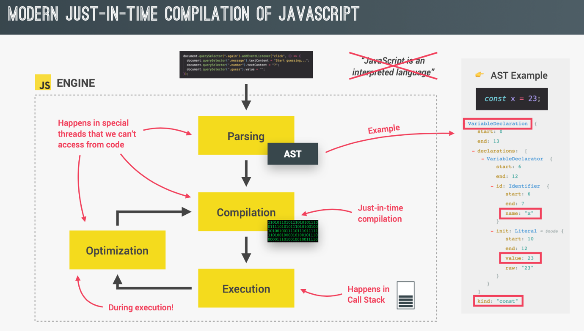

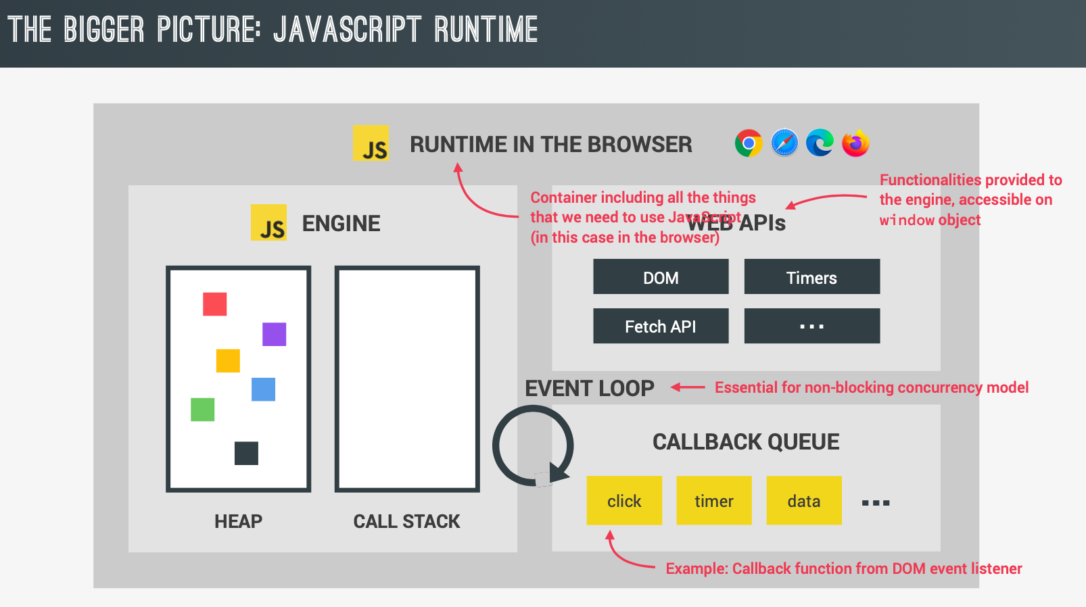

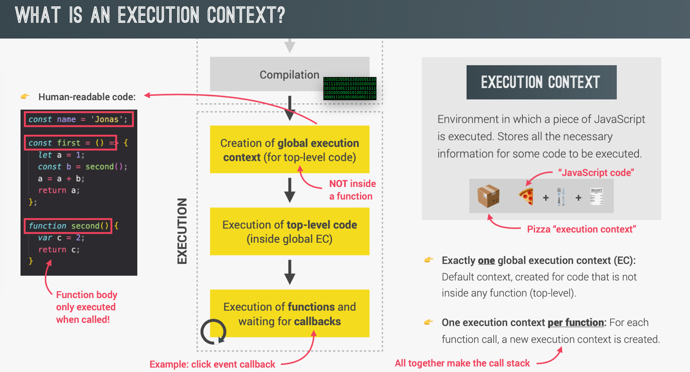

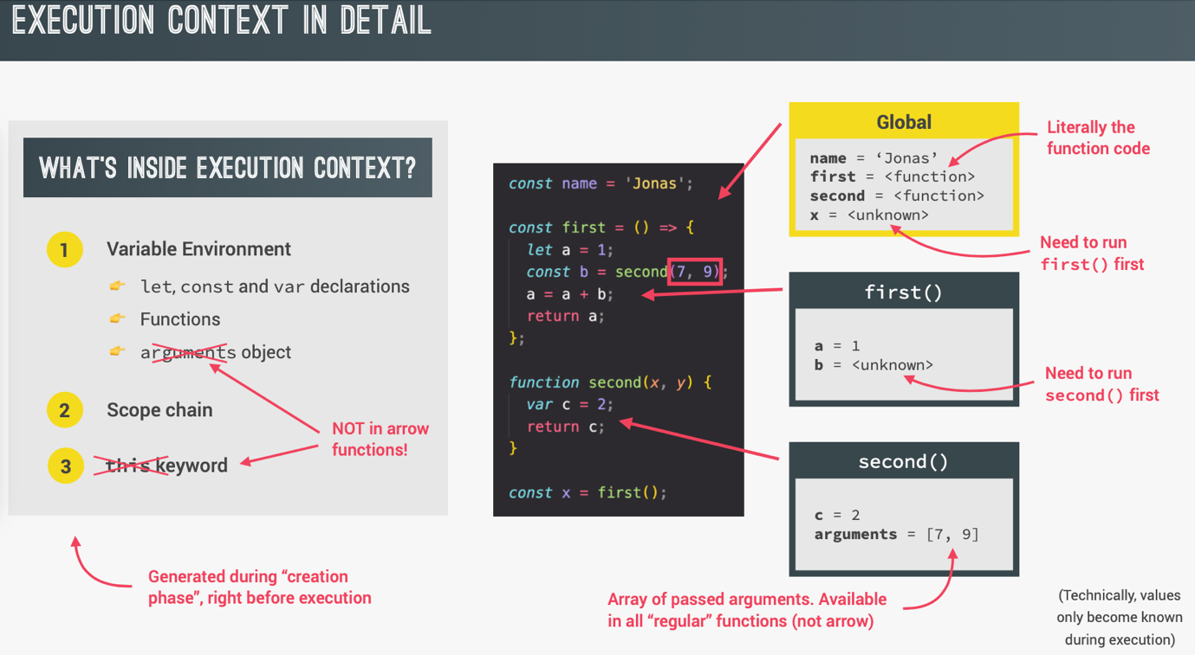

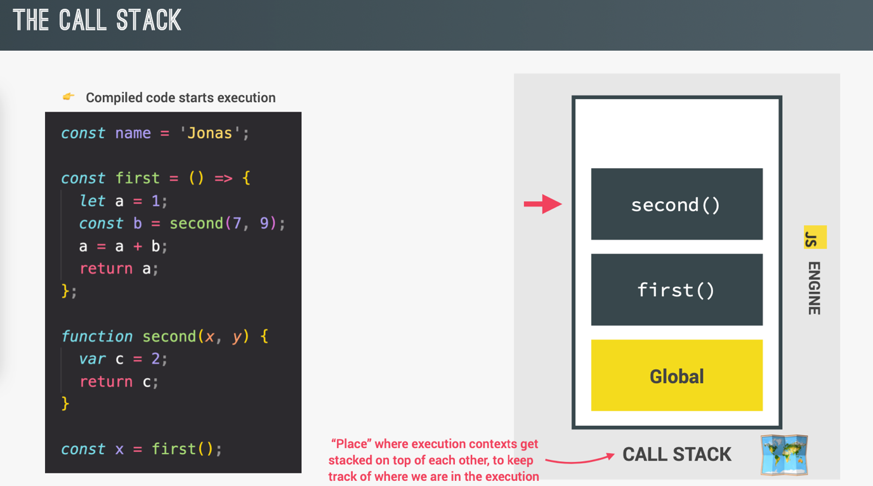

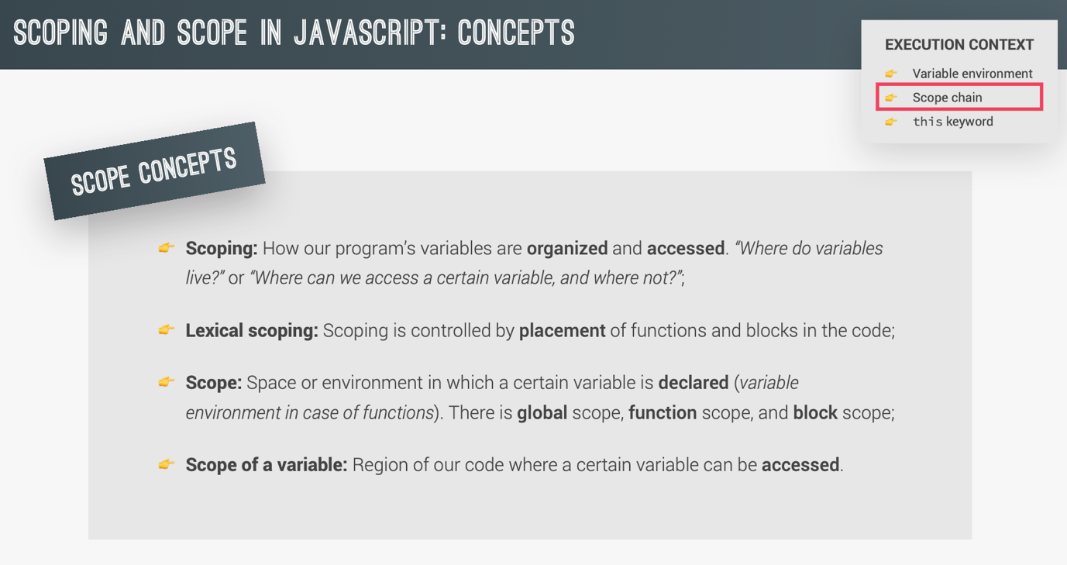

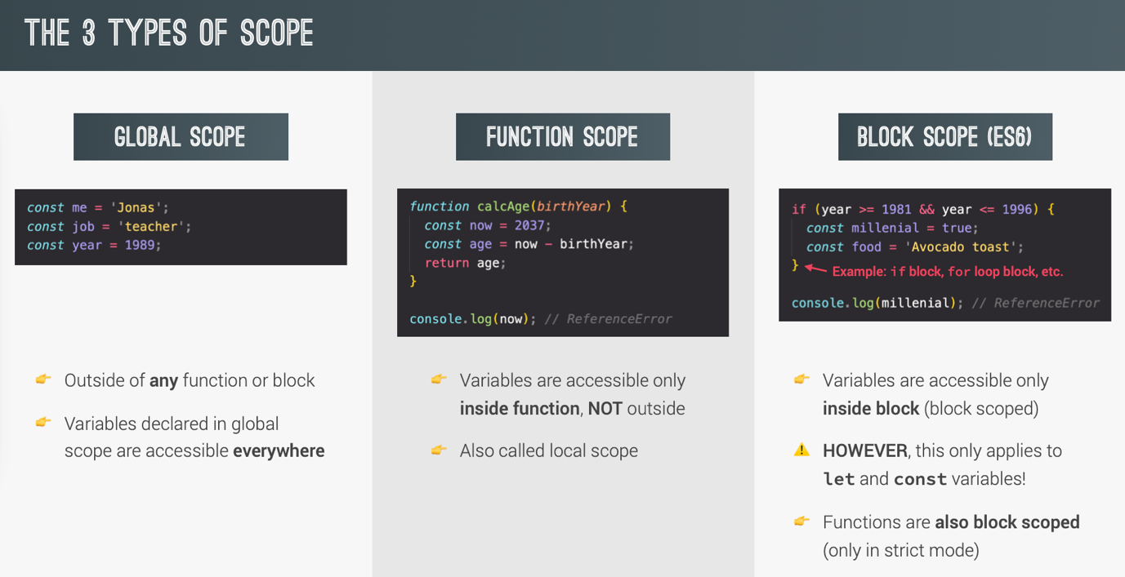

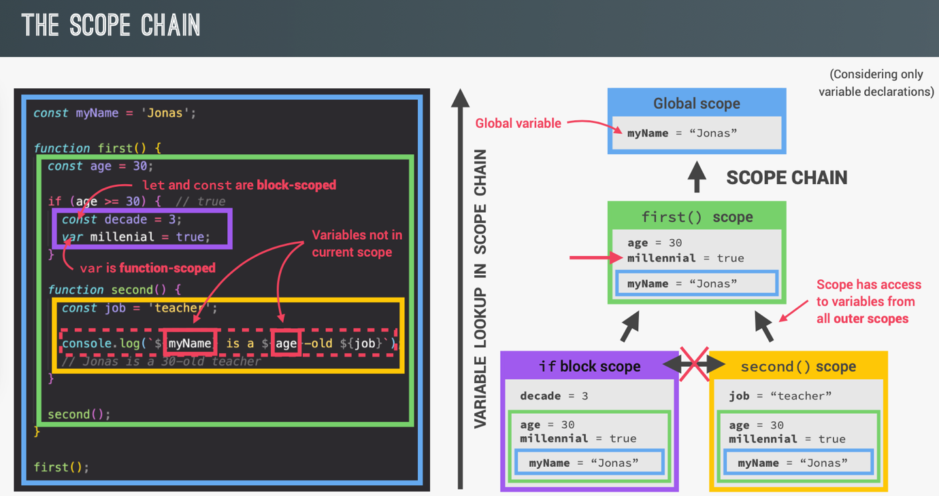

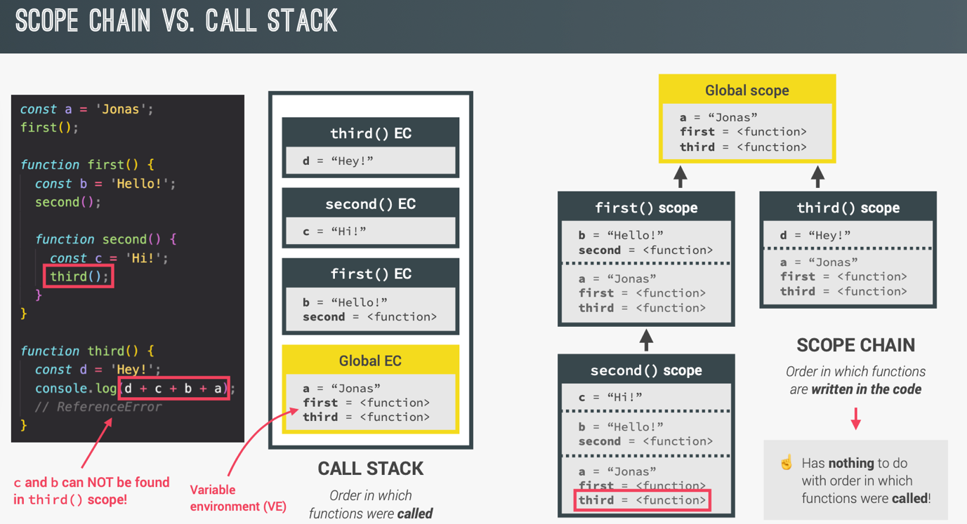

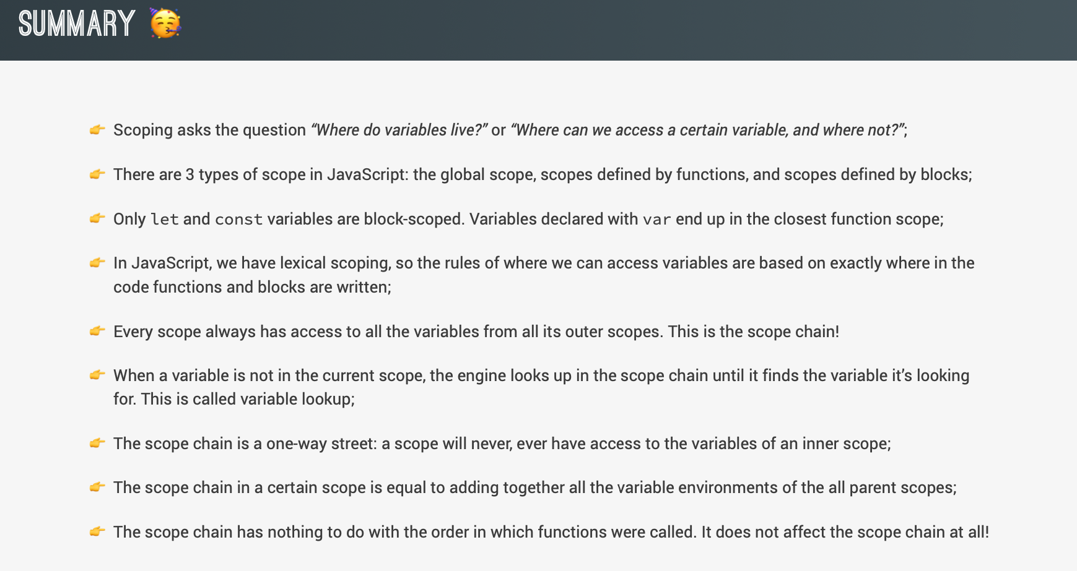

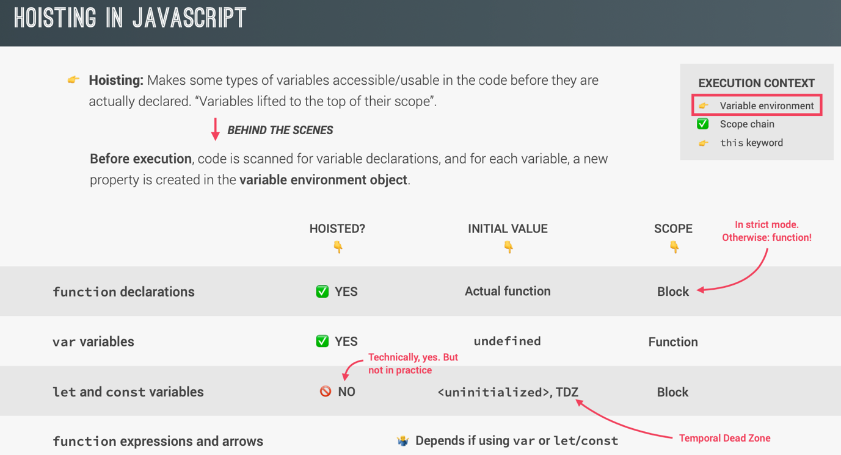

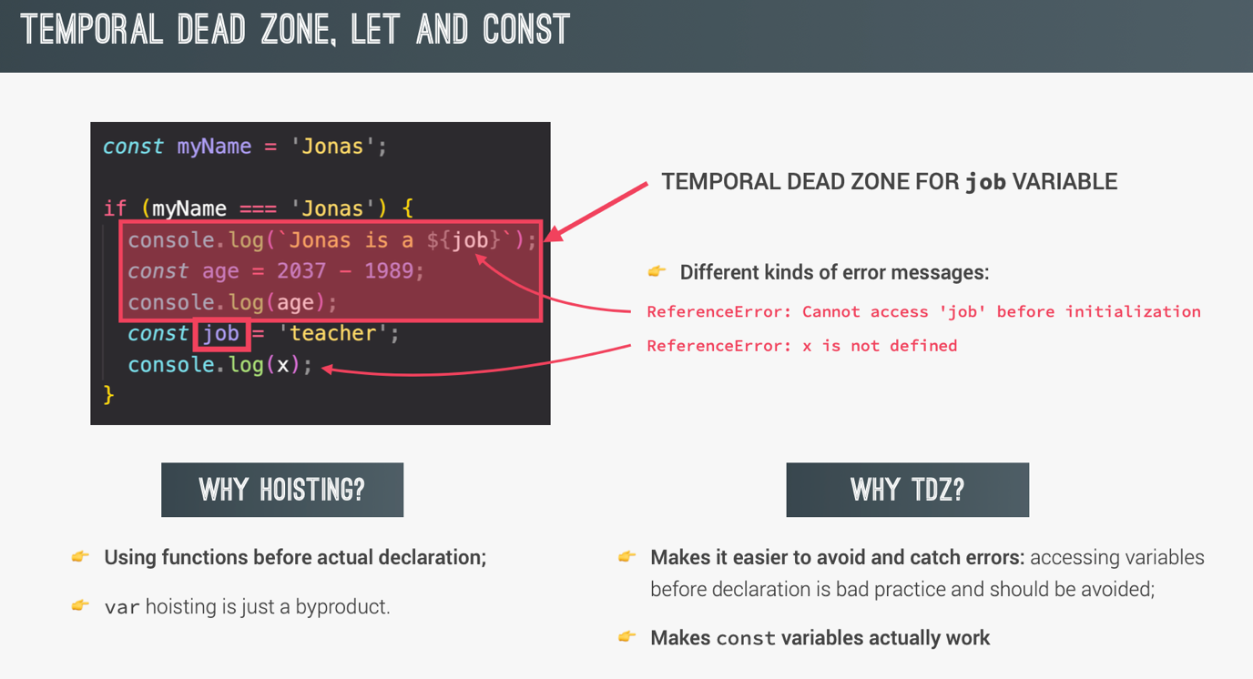

During compile phase, just microseconds before your code is executed, it is scanned for function and variable declarations. All these functions and variable declarations are added to the memory inside a JavaScript data structure called **Lexical Environment**. So that they can be used even before they are actually declared in the source code.

A **lexical environment** is a data structure that holds **identifier-variable mapping**. (here **identifier** refers to the name of variables/functions, and **the variable** is the reference to actual object [including function object] or primitive value).

This is what a lexical environment conceptually look like:

LexicalEnvironment = {

Identifier: <value>,

Identifier: <function object>

}

Remember **JavaScript only hoist declarations, not initializations**. That is, during compile time, JavaScript only stores function and variable declarations in the memory, not their assignments (value).

All declarations (**function, var, let, const and class**) are hoisted in JavaScript, while the **var** declarations are initialized with **undefined**, but **let** and **const** declarations remain **uninitialized**.

**Hoisting Variables**:

1. Hoisting **var** variables:

console.log(a); //undefined

var a = 3; // a will be 3 here.

When JavaScript engine finds a var variable declaration during the compile phase, it will add that variable to the lexical environment and initialize it with **undefined.**

So the initial lexical environment for the above code will look something like this:

lexicalEnvironment = {

a: undefined

}

That’s why we got undefined instead of 3.

And later when the engine reaches the line (during execution) where the actual assignment is done(i.e., at line var a = 3), it will update the value of the variable in its lexical environment. So the lexical environment after the assignment will look like this:

lexicalEnvironment = {

a: 3

}

1. Hoisting **let** variables:

console.log(a); // ReferenceError: Cannot access 'a' before initialization

let a = 3; // a will be 3 here.

Here during the compile phase, the JavaScript engine encounters the variable a and stores it in the lexical environment, but because it’s a let variable, the engine does not initialize it with any value. So during the compile phase, the lexical environment will look like this:

lexicalEnvironment = {

a: <uninitialized>

}

It will be initialized only when assignment is evaluated(lexical binded) successfully during run time by the JavaScript engine at the place when the variable is declared. This means you can’t access the variable before the engine evaluates its value at the place it was declared in the source code. This is what we call “**Temporal Dead Zone**” or **TDZ**, A time span between variable creation and its initialization where they can’t be accessed.

And still if during the assignment evaluation if the JavaScript engine still can’t find the value of let or const variables at the line where they were declared, it will assign them the value of undefined or return an error (in case of const).

Example: where Declaration and assignment happens in two separate statements.

let a;

console.log(a); // undefined

a = 5;

Here during the compile phase, the JavaScript engine encounters the variable a and stores it in the lexical environment, but because it’s a let variable, the engine does not initialize it with any value. So during the compile phase, the lexical environment will look like this:

lexicalEnvironment = {

a: <uninitialized>

}

Now during the execution, when the engine reaches the line where the variable was declared, it will try to evaluate its binding (value), but because the variable has no value associated with it(it is only declared and not initialized at the same place), it will assign it **undefined**.

So the lexical environment will look like this after execution of the first line:

lexicalEnvironment = {

a: undefined

}

And undefined will be logged to the console and after that 5 will be assigned to it and the lexical environment will be updated to contain the value of a to 5 from undefined.

1. Hoisting **const** variables:

console.log(a); // ReferenceError: Cannot access 'a' before initialization

const a = 3; // a will be 3 here.

Similar reasoning to let.

const a;

console.log(a); // Missing initializer in const declaration

a = 5;

**/**Variable Hoisting: Example demonstrating all variables types. */**

console.log(me); //undefined; since var is hoisted as undefined initial value.

console.log(job); //ReferenceError; It’s still in TDZ(Temporal Dead Zone)

console.log(year); // ReferenceError; It’s still in TDZ(Temporal Dead Zone)

var me = ‘Jonas’;

let job = ‘Teacher’;

const year = 1991;

**/**Function Hoisting: Demonstrating all function types. */**

console.log(addDecl(2, 3)); //5; since initial value for function declarations is the value of function itself.

console.log(addExpr(2, 3)); // ReferenceError; It’s still in TDZ(Temporal Dead Zone)

console.log(addArrow(2, 3)); // ReferenceError; It’s still in TDZ(Temporal Dead Zone)

//Function Declaration

function addDecl (a, b) {

return a + b;

}

//Function Expression

const addExpr = function (a, b) {

return a + b;

}

//Arrow Function

const addArrow = (a, b) => a + b;

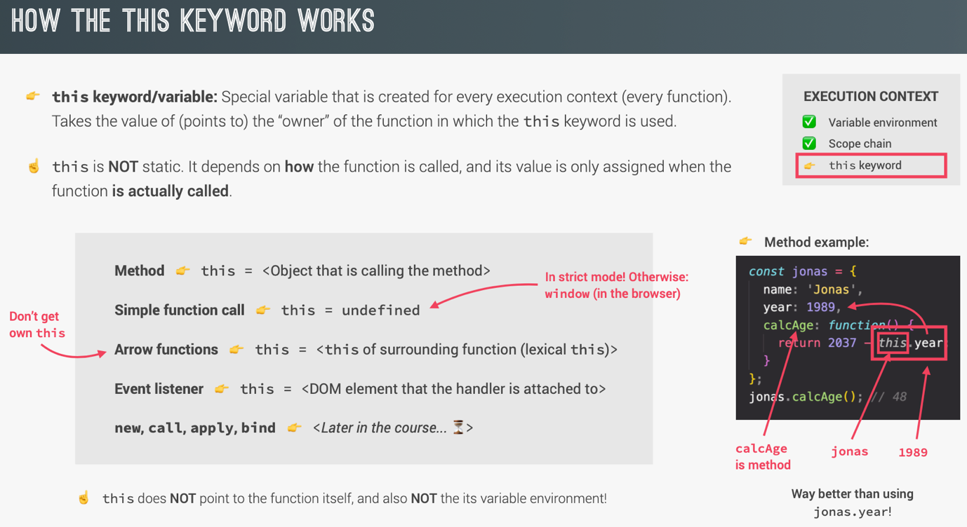

console.log(this); //global window object

const calcAge = function (birthyear) {

console.log(2037 - birthYear);

console.log(this); //undefined; since it is a simple function call.

};

calcAge(1991);

const calcAgeArrow = birthyear => {

console.log(2037 - birthYear);

console.log(this); // global window object; since in arrow function, parent scope’s this is used.

};

calcAgeArrow(1991);

const jonas = {

year: 1991,

calcAge: function() {

console.log(this); //Jonas object; since it is a method call and not a simple function

console.log(2037 – this.year);

}

};

jonas.calcAge();

//Method borrowing

const matilda = {

year: 2017

};

matilda.calcAge = jonas.calcAge;

matilda.calcAge(); //20; since we are calling the method on matilda.

const Jonas = {

firstName: ‘Jonas’,

year: 1991,

calcAge: function () {

console.log(this);

console.log(2037 – this.year);

},

greet: () => console.log(`Hey ${this.firstName}`)

};

jonas.greet(); //Hey undefined; since arrow functions use parent scope, which is global in this case.

**//arguments keyword**

const addExpr = function (a, b) {

console.log(arguments); //prints arguments keyword properties, containing all the arguments passed, even though we have not listed them in parameter list.

return a + b;

};

addExpr(2, 5);

addExpr(2, 5, 8, 12);

const addArrow = (a, b) => {

console.log(arguments); //undefined; since arrow functions do not get argument keyword.

return a + b;

};

addArrow(2, 5);

addArrow(2, 5, 8, 12);

**Primitives vs Objects (Primitive types vs Reference types)**

let age = 30;

let oldAge = 30;

age = 31;

console.log(age); //31

console.log(oldAge); //30

const me = {

name: ‘Jonas’,

age: 30

};

const friend = me;

friend.age = 27; //Perfectly ok. We can change the property of a const object.

console.log(‘Friend: ’, friend); //{name: ‘Jonas’, age: 27}

console.log(‘Me: ’, me); // {name: ‘Jonas’, age: 27}

friend = {}; //Not ok. Since we cannot assign a different object to a const object.

**//Using Object.assign to create object copy.**

const me2 = {

name: ‘Jonas’,

age: 30

};

const meCopy = Object.assign({}, me2); //This actually copies the me2 object and assign it to meCopy. No reference is created here. It’s a real copy and it is created in the heap.

meCopy.age = 22;

console.log(‘meCopy: ’, friend); //{name: ‘Jonas’, age: 22}

console.log(‘Me: ’, me); // {name: ‘Jonas’, age: 27}

// **But using Object.assign will not work for nested objects. It does a shallow copy and not the deep copy or deep clone.**

const me2 = {

name: ‘Jonas’,

age: 30,

friends: [‘Bob’, ‘Alice’]

};

const meCopy = Object.assign({}, me2); //This actually copies the me object and assign it to meCopy. No reference is created here. It’s a real copy and it is created in the heap.

meCopy.age = 22;

meCopy.friends.push(‘Alex’);

console.log(‘meCopy: ’, friend); //{name: ‘Jonas’, age: 22, friends: [‘Bob’, ‘Alice’]}

console.log(‘Me: ’, me); // {name: ‘Jonas’, age: 27, friends: [‘Bob’, ‘Alice’, ‘Alex’]}

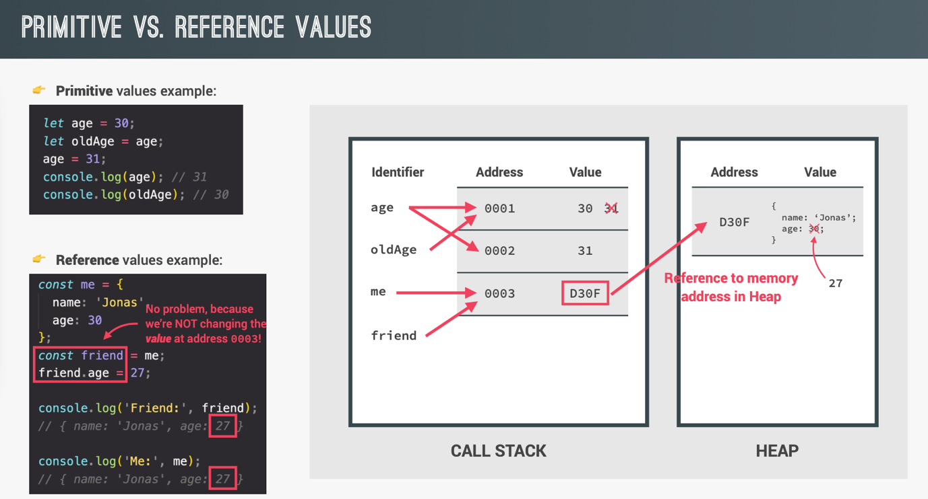

**DATA STRUCTURES, MODERN OPERATORS AND STRINGS**

**Destructuring Array: Unpacking the data.**

**//Example Object to be used throughout.**

*/**ES6 enhanced object literals, Usage 3: Compute property names. */*

*const* weekdays = ['mon', 'tue', 'wed', 'thu', 'fri', 'sat', 'sun'];

*const* openingHours = {

[weekdays[3]]: {

open: 12,

close: 22,

},

[weekdays[4]]: {

open: 11,

close: 23,

},

[weekdays[5]]: {

open: 0, *// Open 24 hours*

close: 24,

},

};

*const* restaurant = {

name: 'Classico Italiano',

location: 'Via Angelo Tavanti 23, Firenze, Italy',

categories: ['Italian', 'Pizzeria', 'Vegetarian', 'Organic'],

starterMenu: ['Focaccia', 'Bruschetta', 'Garlic Bread', 'Caprese Salad'],

mainMenu: ['Pizza', 'Pasta', 'Risotto'],

*// ES6 enhanced object literals, Usage 1: Short property declaration.*

openingHours,

*//Traditional way*

*//openingHours: openingHours,*

*// ES6 enhanced object literals, Usage 2: Short function declaration.*

order(*starterIndex*, *mainIndex*) {

return [*this*.starterMenu[starterIndex], *this*.mainMenu[mainIndex]];

},

*//Traditional way*

*// order: function (starterIndex, mainIndex) {*

*// return [this.starterMenu[starterIndex], this.mainMenu[mainIndex]];*

*// },*

orderDelivery({ *starterIndex* = 1, *mainIndex* = 0, *time* = '20:00', *address* }) {

console.log(

`Order received! ${*this*.starterMenu[starterIndex]} and ${*this*.mainMenu[mainIndex]} will be delivered to ${address} at ${time}`

);

},

orderPasta(*ing1*, *ing2*, *ing3*) {

console.log(

`Here is your declicious pasta with ${ing1}, ${ing2} and ${ing3}`

);

},

orderPizza(*mainIngredient*, ...*otherIngredients*) {

console.log(mainIngredient);

console.log(otherIngredients);

},

};

const arr = [2, 3, 4];

const a = arr[0];

const b = arr[1];

const c = arr[2];

const [x, y, z] = arr; **//Destructuring**

console.log(x, y, z); //2 3 4

**//Destructuring not in sequence**

let [main, , secondary] = restaurant.categories; //We create a hole in our list, by giving an empty param. This skips the item in the array.

console.log(main, secondary); //Italian Vegetarian

[main, secondary] = [secondary, main]; //Swapping two variables. We could have swapped two variables using a third variable temp in usual way, but using destructuring makes it more easier.

console.log(main, secondary); //Vegetarian Italian

console.log(restaurant.order(2, 0)); //Garlic Bread, Pizza

**//Receive two return values from a function**

const [starter, mainCourse] = restaurant.order(2, 0);

console.log(starter, mainCourse); //Garlic Bread, Pizza

**//Destructuring nested array**

const nestedArr = [2, 4, [5, 6]];

const [i, , [j , k]] = nestedArr;

console.log(i , j , k); //2, 5, 6

**//Default values**

const [p, q, r] = [8, 9];

console.log(p, q, r); //8, 9, undefined

const [p = 1, q = 1, r = 1] = [8, 9];

console.log(p, q, r); //8, 9, 1

**Destructuring Object:**

//Property names are important here.

const {name, openingHours, categories } = restaurant;

console.log(name, openingHours, categories);

//But we can change the names as needed.

const {name: restaurantName, openingHours: hours, categories: tags} = restaurant;

console.log(restaurantName, hours, tags);

//Default values

const { menu = [], starterMenu: starters = [] } = restaurant;

console.log(menu, starters);

//Mutating variables

let a = 111;

let b = 999;

const obj = { a: 23, b: 7, c: 14 };

let { a, b } = obj; //Won’t work since a and b are already defined before.

//Do this instead. Wrap them in parenthesis ????

({ a, b } = obj);

console.log(a, b); //23, 7

//Destructuring nested object

const { fri: { open, close } } = openingHours;

console.log(open, close);

//Destructuring in function calls

restaurant.orderDelivery({

time: ’22:30’,

address: ‘Via del sole, 21’,

mainIndex: 2,

starterIndex: 2

});

**Spread Operator(...): (Decompressing)**

Expanding the things.

Used in two situations: Building new things and Creating copy of things.

Iterables are: Arrays, String, Maps, Sets. NOT Objects

const arr = [7, 8, 9];

const newArr = [1, 2, arr[0], arr[1], arr[2]];

console.log(newArr); //[1,2,7,8,9] ENTIRE ARRAY

**//Useful in building array from another array**

const newArr = [1, 2, ...arr];

console.log(newArr); //[1,2,7,8,9]; ENTIRE ARRAY

console.log(...newArr); //1 2 7 8 9; INDIVIDUAL VALUES AND NOT THE ENTIRE ARRAY

**//Copy Array**

const mainMenuCopy = [...restaurant.mainMenu]; //Similar to Object.assign; it also creates a shallow copy

**//Join Array**

const menu = [...restaurant.mainMenu, ...restaurant.starterMenu];

const str = ‘Jonas’;

const letters = [...str, ‘’, ‘S’];

console.log(letters); //[”J”, “o”, “n”, “a”, “s”, “”, “S”]

**//Useful in passing arguments to a function call.**

const ingredients = [

prompt(“Let’s make pasta! Ingredient 1?”),

prompt(“Ingredient 2?”),

prompt(“Ingredient 3?”)

];

console.log(ingredients);

restaurant.orderPasta(ingredient[0], ingredient[1], ingredient[2]); //Old style

restaurant.orderPasta(...ingredients); //More preferred way!

**//Useful in building objects from other objects**

const newRestaurant = { foundedIn: 1998, ...restaurant, founder: ‘Guiseppe’ };

console.log(newRestaurant); //logs new restaurant object containing new properties as well.

**//Useful in creating copy of objects**

const restaurantCopy = { ...restaurant };

restaurantCopy.name = ‘Ristorante Roma’;

console.log(restaurantCopy.name); //‘Ristorante Roma’

console.log(restaurant.name); //’Classico Italiano’

**REST PATTERN AND PARAMETERS: (Compressing)**

Rest operator is similar to spread operator, but works in opposite way.

Rest operation takes in multiple values and packs them. It is opposite of spread operator.

There can only be one Rest element and that too must be at the last in any destructuring assignment.

//1) DESTRUCTURING

//SPREAD, because on RIGHT side of =

const arr = [1, 2, ...[3, 4]];

//REST, because on LEFT side of =

const [a, b, ...others] = [1, 2, 3, 4, 5];

console.log(a, b, others); //1, 2, [3, 4, 5]

const { sat, ...weekdays } = restaurant.openingHours;

console.log(weekdays);

//2) FUNCTIONS

//Function accepting multiple params; known at run time.

const add = function(...numbers) {

let sum = 0;

for (let i = 0; i < numbers.length; i++) {

sum += numbers[i];

console.log(sum);

}

}

add(2, 3); //5

add(5, 3, 7, 2); // 17

const x = [23, 5, 7];

add(...x); //35

**Short Circuiting(&& and ||):**

Use any data type, return any data type and short circuiting.

/** OR operator */

console.log(3 || ‘Jonas’); //3, short circuiting; since 3 is truthy value, second param is not even evaluated.

console.log(‘’ || ‘Jonas’); //Jonas

console.log(true || 0); //true

console.log(undefined || null); //null

console.log(undefined || 0 || ‘’ || ‘Hello’ || 23 || null); //Hello, it the first truthy value in the chain of operation.

/**Traditional operation */

const guest1 = restaurant.numGuests ? restaurant.numGuests : 10;

console.log(guest1); //10

/**Short circuited operation */

const guest2 = restaurant.numGuests || 10;

console.log(guest2); //10

/** AND operator */

console.log(0 && ‘Jonas’); //0

console.log(‘Hello’ && 23 && null && ‘Jonas’); //null

/**Nullish Coalescing operator (??)*/

restaurant.numGuests = 0;

const guests = restaurant.numGuests || 10;

console.log(guests); //10; since 0 is falsy value, further expression is evaluated and assigned the value of 10. This is a problem, because guests can also be 0. How do we handle that.

/**Nullish: null and undefined (NOT 0 or ‘’) */

restaurant.numGuests = 0;

const guestsCorrect = restaurant.numGuests ?? 10;

console.log(guestsCorrect); // 0; this is correct now

**For-of-loop:**

const menu = [...restaurant.starterMenu, ...restaurant.mainMenu];

for (const item of menu) {

console.log(item); // logs items in array

}

**Enhanced Object Literal:**

Usage:

1. Short property declaration
2. Short function declaration
3. Compute property names

*/**ES6 enhanced object literals, Usage 3: Compute property names. */*

*const* weekdays = ['mon', 'tue', 'wed', 'thu', 'fri', 'sat', 'sun'];

*const* openingHours = {

[weekdays[3]]: {

open: 12,

close: 22,

},

[weekdays[4]]: {

open: 11,

close: 23,

},

[weekdays[5]]: {

open: 0, *// Open 24 hours*

close: 24,

},

};

*const* restaurant = {

name: 'Classico Italiano',

location: 'Via Angelo Tavanti 23, Firenze, Italy',

categories: ['Italian', 'Pizzeria', 'Vegetarian', 'Organic'],

starterMenu: ['Focaccia', 'Bruschetta', 'Garlic Bread', 'Caprese Salad'],

mainMenu: ['Pizza', 'Pasta', 'Risotto'],

*// ES6 enhanced object literals, Usage 1: Short property declaration.*

openingHours,

*//Traditional way*

*//openingHours: openingHours,*

*// ES6 enhanced object literals, Usage 2: Short function declaration.*

order(*starterIndex*, *mainIndex*) {

return [*this*.starterMenu[starterIndex], *this*.mainMenu[mainIndex]];

},

*//Traditional way*

*// order: function (starterIndex, mainIndex) {*

*// return [this.starterMenu[starterIndex], this.mainMenu[mainIndex]];*

*// },*

orderDelivery({ *starterIndex* = 1, *mainIndex* = 0, *time* = '20:00', *address* }) {

console.log(

`Order received! ${*this*.starterMenu[starterIndex]} and ${*this*.mainMenu[mainIndex]} will be delivered to ${address} at ${time}`

);

},

orderPasta(*ing1*, *ing2*, *ing3*) {

console.log(

`Here is your declicious pasta with ${ing1}, ${ing2} and ${ing3}`

);

},

orderPizza(*mainIngredient*, ...*otherIngredients*) {

console.log(mainIngredient);

console.log(otherIngredients);

},

};

**Optional Chaining operator (?.):**

//Without optional chaining.

Console.log(restaurant.openingHours.mon.open); //TypeError: Cannot read property ‘open’ of undefined

//Using optional chaining.

console.log(restaurant.openingHours.mon?.open); //Undefined; Since it works only if the property before ? exists, only then the next property will be read from there. Otherwise undefined is returned immediately.

//Traditional property existence check, can get out of hand for deeply nested objects.

if (restaurant.openingHours && restaurant.openingHours.mon) {

console.log(restaurant.openingHours.mon.open);

}

//Using optional chaining

console.log(restaurant.openingHours?.mon?.open);

**Looping Objects:**

//Looping over property names

const properties = Object.keys(openingHours);

for (const day of properties) {

console.log(day); //thu, fri, sat

}

//Looping over values.

const values = Object.values(openingHours);

for (const hours of values) {

console.log(hours.open); //12, 11, 0

}

//Looping entire object.

const entries = Object.entries(openingHours);

//Destructuring it also.

for (const [key, {open, close}] of entries) {

console.log(`On ${key} we open at: ${open} and close at: ${close}`);

}

**Sets:**

Collection of unique values. Order of elements is irrelevant.

const ordersSet = new Set([‘Pasta’, ‘Pizza’, ‘Pizza’, ‘Risotto’, ‘Pasta’, ‘Pizza’]);

console.log(ordersSet); //{‘Pasta’, ‘Pizza’, ‘Risotto’}

console.log(new Set(‘Jonas’)); //{‘J’, ‘o’, ‘n’, ‘a’, ‘s’}

/**Methods on sets */

console.log(ordersSet.size); //3

console.log(ordersSet.has(‘Pizza’)); //true

ordersSet.add(‘Garlic Bread’);

console.log(ordersSet); //{‘Pasta’, ‘Pizza’, ‘Risotto’, ‘Garlic Bread’}

ordersSet.delete(‘Risotto’);

console.log(ordersSet); //{‘Pasta’, ‘Pizza’, ‘Garlic Bread’}

//ordersSet.clear(); //Deletes entire set.

//console.log(ordersSet); //{}

for (const order of ordersSet) {

console.log(order); //Items one by one

}

**Maps:**

Collection of key value pairs. But unlike objects, a key in a map could be anything and not only string.

const rest = new Map();

rest.set(‘name’, ‘Classico Italiano’);

rest.set(1, ‘Firenze, Italy’); //Add new item and returns the set. This allows use to chain series of set operations.

console.log(rest.set(2, ‘Lisbon, Portugal’)); // Prints the map.

//**Chaining of set operations */

rest

.set(‘categories’, [‘Italian’, ‘Pizzeria’, ‘Vegetarian’, ‘Organic’])

.set(‘open’, 11)

.set(‘close’, 23)

.set(true, ‘We are open’)

.set(false, ‘We are closed’);

console.log(rest.get(‘name’)); //Classico Italiano

console.log(rest.get(true)); //We are open

console.log(rest.get(1)); // Firenze, Italy

const time = 8;

const isOpen = rest.get(time > rest.get(‘open’) && time < rest.get(‘close’));

console.log(isOpen); //We are closed

/**Methods on maps */

console.log(rest.has(‘categories’)); //true

rest.delete(2); //Deletes the property named 2 from the map

console.log(rest.size); //7

//rest.clear(); //Deletes all elements from the map.

const arr = [1, 2];

rest.set(arr, ‘Test’); //Storing array as key in map.

console.log(rest.get(arr)); // Test

/**Building map without using set method */

const question = new Map([

[‘question’, ‘What is the best programming language?’],

[1, ‘C’],

[2, ‘Java’],

[3, ‘JavaScript’],

[‘correct’, 3],

[true, ‘Correct🎉’],

[false, ‘Try again!’]

]);

console.log(question);

/**Convert Object to Map */

console.log(Object.entries(openingHours));

const hoursMap = new Map(Object.entries(openingHours));

console.log(hoursMap);

/**Iteration on Maps */

for (const [key, value] of question) {

if (typeof key === ‘number’) {

console.log(`Answer ${key}: ${value}`)

}

}

/**Convert Map to array */

console.log([...question]);

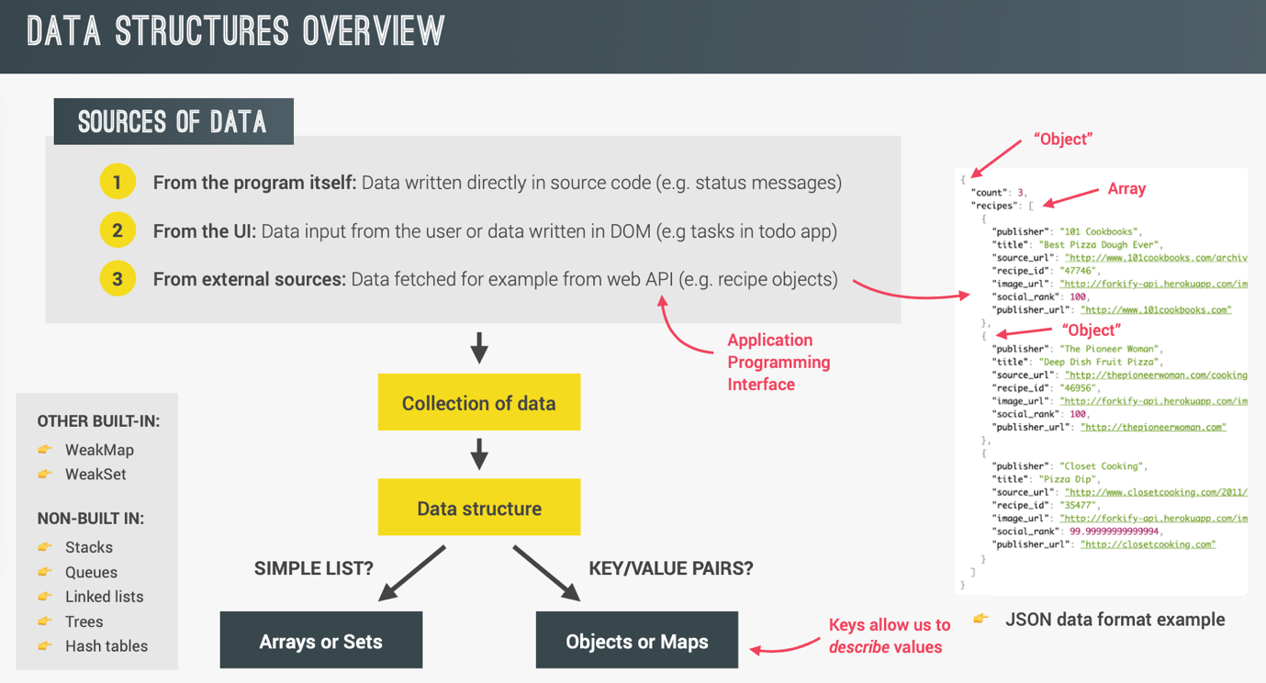

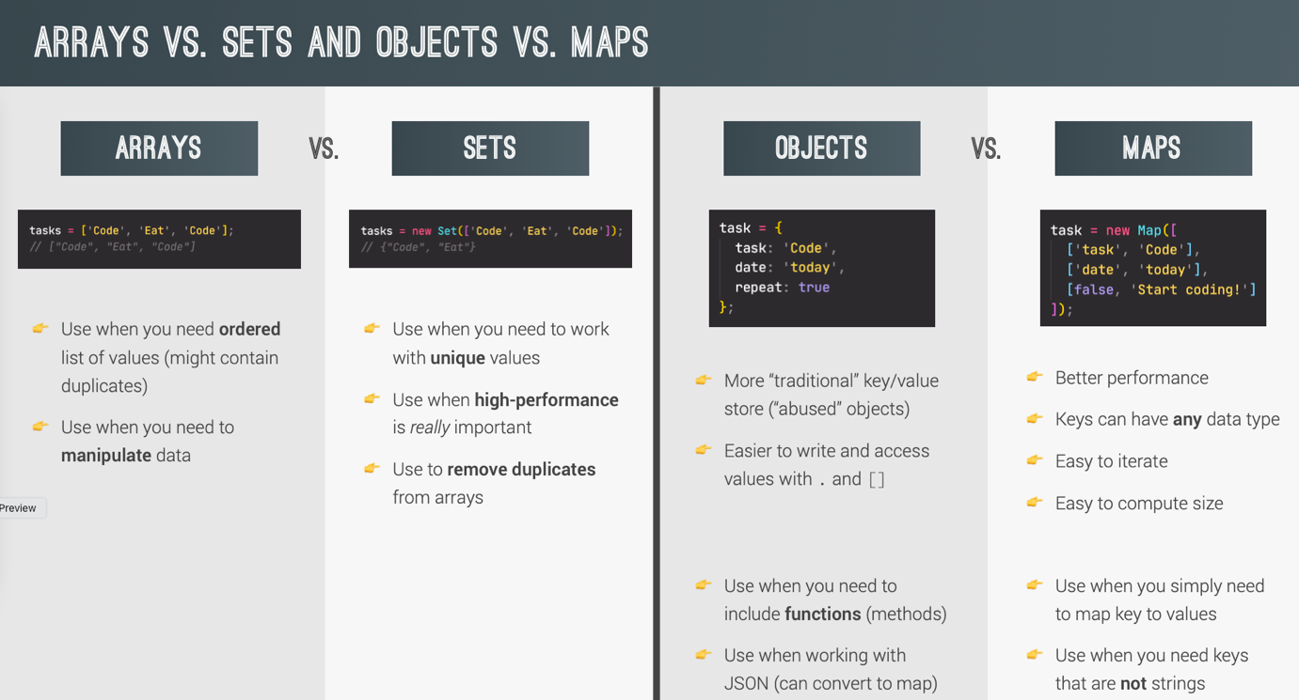

**Strings:**

const airline = ‘TAP Air Portugal’;

console.log(airline[0]); // T

console.log(airline.length); //16

/**Methods */

console.log(airline.indexOf(‘r’)); //6

console.log(airline.lastIndexOf(‘r’)); //10

console.log(airline.indexOf(‘Portugal’)); //8

console.log(airline.slice(4)); // Air Portugal; slice(begin); end is by default till the string ends.

console.log(airline.slice(4, 7)); //Air; slice(begin, end), end is not included

console.log(airline.slice(0, airline.indexOf(‘ ’))); //TAP

console.log(airline.slice(airline.lastIndexOf(‘ ’) + 1)); //Portugal

console.log(airline.slice(-2)); //al; negative indices denotes starting from end.

console.log(airline.slice(1, -1)); //AP Air Portuga

console.log(airline.toLowerCase()); //tap air portugal

console.log(airline.toUpperCase()); //TAP AIR PORTUGAL

const email = ‘ Hello@Jonas.Io \n’;

const lowerEmail = email.toLowerCase(); // ‘ hello@jonas.io \n’

const trimmedEmail = lowerEmail.trim(); // hello@jonas.io

/**Chaining string operations */

const finalEmail = email.toLowerCase().trim(); // hello@jonas.io

/**replace, includes, startsWith and endsWith */

const priceGB = ‘288,97￡’

const priceUS = priceGB.replace(‘￡’, ‘＄’).replace(‘,’, ‘.’);

console.log(airline.includes(‘TAP’)); //true

console.log(airline.startsWith(‘TAP’)); //true

console.log(airline.endsWith(‘TAP’)); //false

/**split and join */

const [firstName, lastName ] = console.log(‘Jonas Schmedtmann’.split(‘ ’));

const newname = [‘Mr.’, firstName, lastName.toUpperCase()].join(‘ ’);

console.log(newName); //Mr. Jonas SCHMEDTMANN

**A CLOSER LOOK AT FUNCTIONS**

**Default parameters:**

const bookings = [];

/**ES5: Traditional way of assigning default parameter value */

const createBooking = function(flightNum, numPassengers, price) {

numPassengers = numPassengers || 1;

price = price || 199;

const booking = {

flightNum,

numPassengers,

price

}

console.log(booking);

bookings.push(booking);

}

createBooking(‘LH123’); //{‘flightNum’: ‘LH123’, ‘numPassengers’: undefined, ‘price’: undefined}

/**ES6: Modern way*/

const createBooking = function(flightNum, numPassengers = 1, price = 199) {

const booking = {

flightNum,

numPassengers,

price

}

console.log(booking);

bookings.push(booking);

}

createBooking(‘LH123’); //{‘flightNum’: ‘LH123’, ‘numPassengers’: 1, ‘price’: 199}

/**Skipping default params. */

createBooking(‘LH123’, undefined, 1000) //{‘flightNum’: ‘LH123’, ‘numPassengers’: 1, ‘price’: 1000}

**How passing argument works: Value vs Reference**

const flight = ‘LH234’;

const Jonas = {

name: ‘Jonas Schmedtmann’,

passport: 23242368734631

}

const checkIn = function (flightNum, passengers) {

flightNum = ‘LH999’;

passenger.name = ‘Mr. ’ + passenger.name;

}

checkIn(flight, jonas); //Primitive(flight string) is passed by value, but the obeject is passed as reference

console.log(flight); //Same; no change

console.log(jonas); //Changed

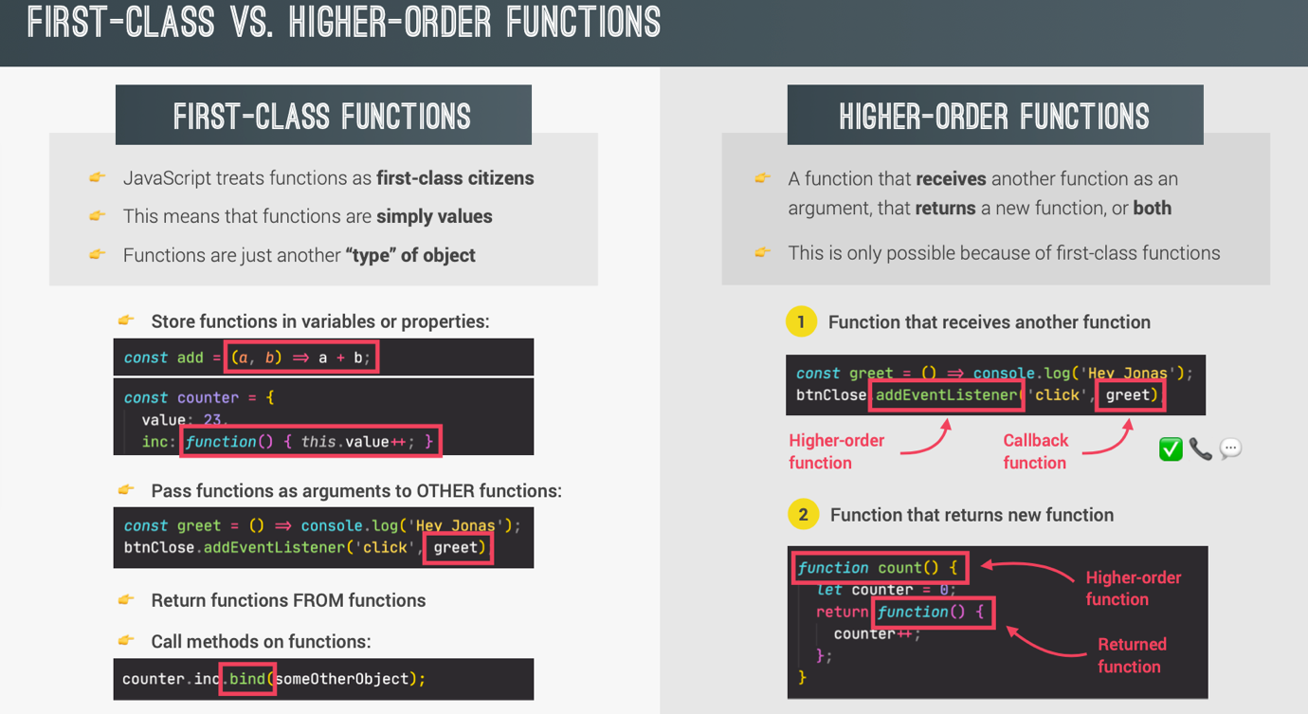

Functions have methods and also properties. We can access these properties and can also call these methods.

**Functions accepting Callback functions:**

const oneWord = function(str) {

return str.replace(/ /g, ‘’).toLowerCase();

}

const upperFirstWord = function(str) {

const [first, ...others] = str.split(‘ ‘);

return [first.toUpperCase(), ...others].join(‘ ‘);

}

/**Higher order function: Since it takes function as argument. */

const transformer = function(str, fn) {

console.log(`Transformed string: ${fn(str)}`); //JAVASCRIPT is the best

console.log(`Transformed by: ${fn.name}`); //upperFirstWord

}

transformer(‘JavaScript is the best’, upperFirstWord);

**Functions Returning functions:**

const greet = function(greeting) {

return function(name) {

console.log(`${greeting} ${name}`);

};

}

const greeterHey = greet(‘Hey’);

greeterHey(‘Jonas’); //Hey Jonas

greet(‘Hello’)(‘Jonas’); //Hello Jonas

**The call and apply methods:**

Explicitly allows to set the ‘this’ keyword

const Lufthansa = {

airline: ‘Lufthansa’,

iataCode: ‘LH’,

bookings: [],

book(flightNum, name) {

console.log(`${name} booked a seat on ${this.airline} flight ${this.iataCode}${flightNum}`);

this.bookings.push({

flight: `${this.iataCode}${flightNum}`,

name

});

},

};

lufthansa.book(239, ‘Jonas Schmedtmann’);

lufthansa.book(635, ‘John Smith’);

const eurowings = {

airline: ‘EuroWings,

iataCode: ‘EW,

bookings: [],

};

const book = lufthansa.book; //Now book becomes a normal function and not a method. So ‘this’ will be undefined.

book(23, ‘Sarah Williams’); //TypeError: ‘this’ is undefined in regular function calls

/**Explicitly set the this keyword: call method */

book.call(eurowings, 23, ‘Sarah Williams’); //First argument denotes the ‘this’

book.call(Lufthansa, 239, ‘Mary Cooper’);

/**apply method: similar to call method, with the only difference that it takes array of arguments after first argument. */

const flightData = [583, ‘George Cooper’];

book.apply(eurowings, flightData);

/**Using spread operator with call to achieve apply method like functionality */

book.call(eurowings, ...flightData);

**Bind Method:**

Also Explicitly allows to set the ‘this’ keyword like call and apply methods, but bind method does not call the function, it returns a new function with bound ‘this’.

/**bind method */

const bookEW = book.bind(eurowings); //bind method returns a function call, which has the ‘this’ keyword set to eurowings object.

bookEW(23, ‘Steven Williams’);

**Immediately Invoked Function Expressions (IIFE):**

Sometimes we need a function that is executed only once while it is created and then never again.

/**Normal functions */

const runOnce = function() {

console.log(‘This will never run again’);

};

runOnce();

/**IIFE */

(function() {

console.log(‘This will never run again’);

})();

**Closures:**

/**Example 1 */

const secureBooking = function() {

let passengerCount = 0;

return function() {

passengerCount++;

console.log(`${passengerCount} passengers`);

}

};

const booker = secureBooking();

booker(); //1 passengers

booker(); //2 passengers

booker(); //3 passengers

/**Example 2 */

let f;

const g = function() {

const a = 23;

f = function() {

console.log(a * 2);

}

}

g(); //Function takes first birth here.

f(); //46; since it remembers variables at its birth place(ie..closure)

/**Example 3 */

const h = function() {

const b = 777;

f = function() {

console.log(b * 2);

}

}

g(); //Function takes first birth here.

f(); //46; since it remembers variables at its birth place(ie..closure)

//Re-assigning f function

h(); //Function takes second birth here.

f(); //1554; since it remembers variables at its birth place(ie..closure)

/**Example 4 */

const boardPassengers = function(n, wait) {

const perGroup = n / 3;

setTimeout(function() {

console.log(`We are now boarding all ${n} passengers`);

console.log(`There are 3 groups, each with ${perGroup} passengers`);

}, wait * 1000);

console.log(`Will start boarding in ${wait} seconds`);

}

boardPassengers(180, 3); //variables n and perGroup in setTimeout can be used even after boardPassengers function has finished its execution(it will not wait for timeout to finish). It is happening only because of the closure

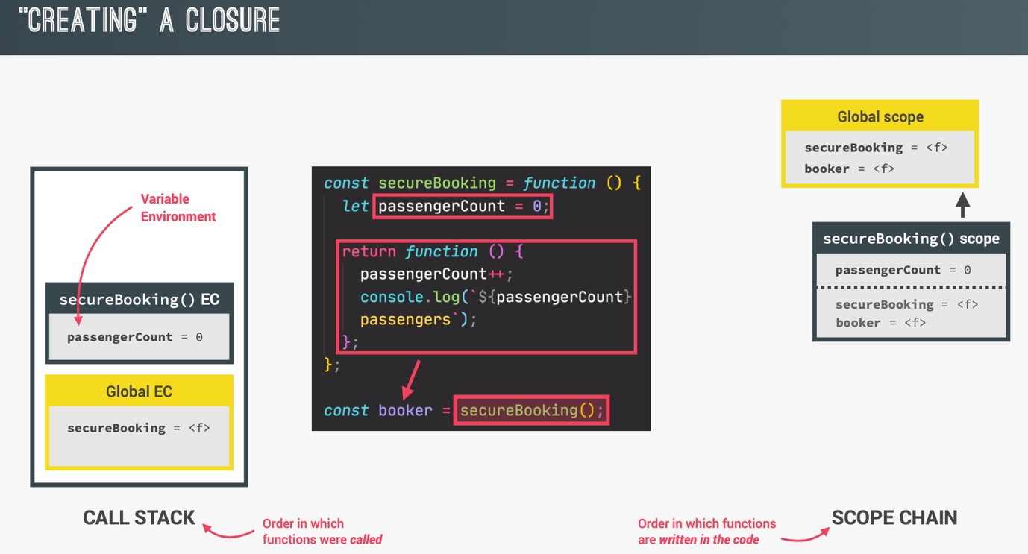

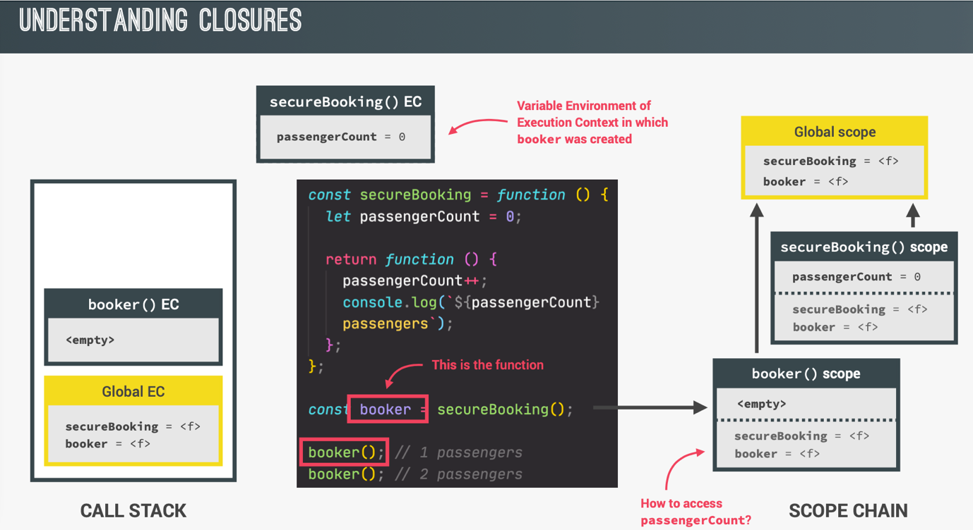

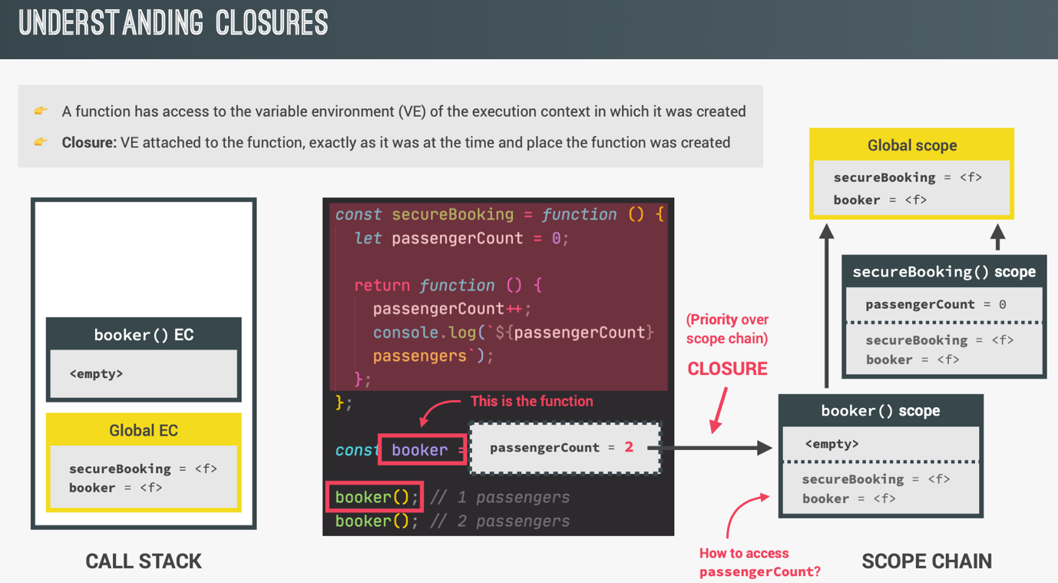

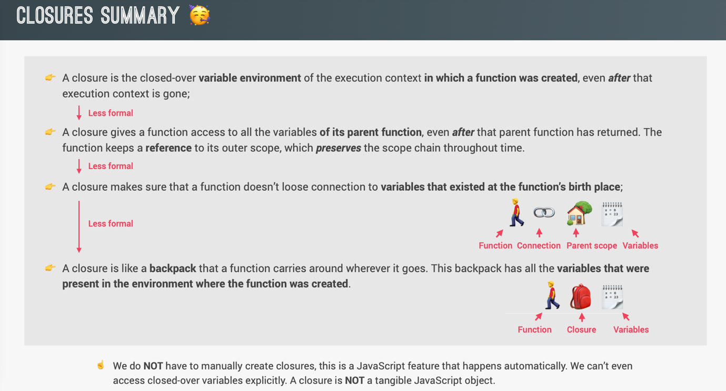

**WORKING WITH ARRAYS:**

**Simple Array methods:**

/**1 slice: Does not modify original array. */

let arr = [‘a’, ‘b’, ‘c’, ‘d’, ‘e’];

console.log(arr.slice(2)); //creates a new array with extracted elements starting from index 2 till end; [‘c’, ‘d’, ‘e’]

console.log(arr.slice(2, 4)); //creates a new array with extracted elements starting from index 2 till 4; [‘c’, ‘d’]

console.log(arr.slice(-2)); //creates a new array with 2 extracted elements starting from the end; [‘d’, ‘e’]

console.log(arr.slice(1, -2)); //creates a new array with 2 extracted elements starting from 1 and except the 2 elements at the end; [‘b’, ‘c’]

/**2 splice: It modifies the original array */

console.log(arr.splice(2)); // [‘c’, ‘d’, ‘e’]

console.log(arr); //[‘a’, ‘b’]; it modifies original data

/**3 reverse: It modifies the original array *

const arr = [‘a’, ‘b’, ‘c’, ‘d’, ‘e’];

const arr2 = [‘j’, ‘i’, ‘h’, ‘g’, ’f’];’

console.log(arr2.reverse()); //[‘f’, ‘g’, ‘h’, ‘i’, ‘j’]

console.log(arr2); //[‘f’, ‘g’, ‘h’, ‘i’, ‘j’];

/**4 concat: It does not mutates original data. */

const letters = arr.concat(arr2);

console.log(letters); //[‘a’, ‘b’, ‘c’, ‘d’, ‘e’, ‘f’, ‘g’, ‘h’, ‘i’, ‘j’];

/**5 join: */

console.log(arr.join(‘-’)); //[a-b-c-d-e]

**Looping Arrays: forEach**

const movements = [200, 450, -400, 3000, -650, -130, 70, 1300];

/**Looping using for...of loop. */

for (const movement of movements) {

if (movement > 0) {

console.log(`You deposited: ${movement}`);

}

else {

console.log(`You withdrew: ${Math.abs(movement)}`);

}

}

/**Looping using for...of loop with access to the current index. */

for (const [i, movement] of movements.entries()) {

if (movement > 0) {

console.log(`Movement ${i+1}: You deposited: ${movement}`);

}

else {

console.log(`Movement ${i+1}: You withdrew: ${Math.abs(movement)}`);

}

}

/**Looping using forEach */

movements.forEach(function(movement) {

if (movement > 0) {

console.log(`You deposited: ${movement}`);

}

else {

console.log(`You withdrew: ${Math.abs(movement)}`);

}

});

/**Looping using forEach with access to the current index. Ordering of parameters is important. First is the current element, then the current index, then the entire array.

continue and break statements don’t run in forEach loop.

*/

movements.forEach(function(movement, index, array) {

if (movement > 0) {

console.log(`Movement ${index+1}: You deposited: ${movement}`);

}

else {

console.log(`Movement ${index+1}: You withdrew: ${Math.abs(movement)}`);

}

});

**Data Transformations: map, filter, reduce**

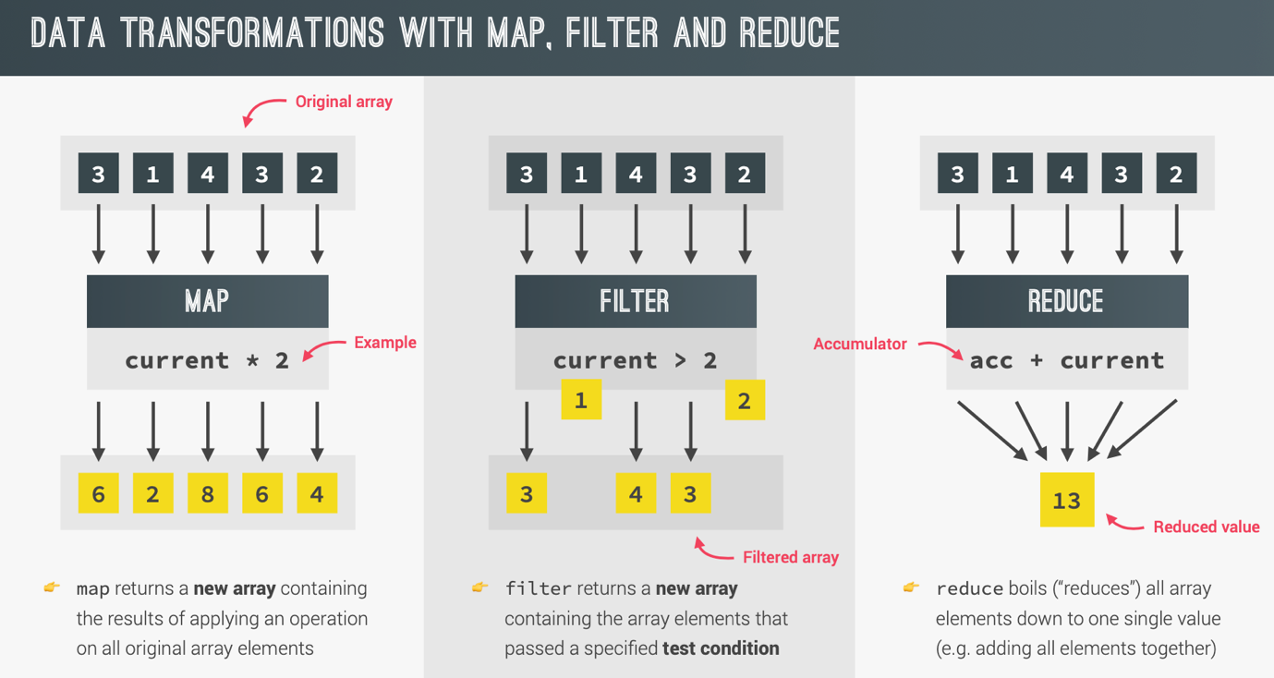

**map method:**

It returns a new array unlike the forEach method, which works on the original array.

const movements = [200, 450, -400, 3000, -650, -130, 70, 1300];

const eurToUsd = 1.1;

const movementsUSD = movements.map(function(movement) {

return movement * eurToUsd;

});

console.log(movementsUSD);

/**Using arrow functions */

const movementsUSD = movements.map(movement => movement * eurToUsd);

const movementsDescriptions = movements.map((movement, index) =>

`Movement ${index+1}: You ${movement > 0 ? ‘deposited’ : ‘withdrew’} ${Math.abs(movement)}`

);

console.log(movementsDescriptions);

**filter method:**

const movements = [200, 450, -400, 3000, -650, -130, 70, 1300];

const deposits = movements.filter(function(movement) {

return movement > 0;

});

console.log(deposits); //[200, 450, 3000, 70, 1300]

**reduce method:**

const movements = [200, 450, -400, 3000, -650, -130, 70, 1300];

const balance = movements.reduce(function(accumulator, movement) {

return accumulator + movement;

}, 0);

console.log(balance);

**The Magic of chaining methods:**

const movements = [200, 450, -400, 3000, -650, -130, 70, 1300];

const eurToUsd = 1.1;

const totalDepositsInUSD = movements

.filter(movement => movement > 0)

.map(movement => movement * eurToUsd)

.reduce((acc, movement) => acc + movement, 0);

console.log(totalDepositsInUSD);

**find method:**

Returns the first element which satisfies the given condition.

const movements = [200, 450, -400, 3000, -650, -130, 70, 1300];

const firstWithdrawal = movements.find(movement => movement < 0);

console.log(firstWithdrawl); //-400

**findIndex method:**

Returns the index of the first element which satisfies the given condition.

const movements = [200, 450, -400, 3000, -650, -130, 70, 1300];

const firstWithdrawalIndex = movements.findIndex(movement => movement < 0);

console.log(firstWithdrawalIndex); //2

**includes method:**

Checks if array includes the given value or not. It only checks for equality condition, but not any other condition.

const movements = [200, 450, -400, 3000, -650, -130, 70, 1300];

console.log(movements.includes(-130)); //true

**some method:**

Checks if there is some value in the array that satisfies the given condition or not.

const movements = [200, 450, -400, 3000, -650, -130, 70, 1300];

const anyDeposits = movements.some(movement => movement > 5000);

console.log(anyDeposits); //false

**every method:**

Checks if all values in the array that satisfies the given condition or not.

const movements = [200, 450, -400, 3000, -650, -130, 70, 1300];

const anyDeposits = movements.every(movement => movement > 0);

console.log(anyDeposits); //false

**flat method:**

Removes the nested array and flattens the array. Default it flattens till 1 level of nesting. But we can give an optional parameter to specify the level of nesting till where we want it to be flattened.

const arr = [[1, 2, 3], [4, 5, 6], 7, 8];

console.log(arr.flat()); //[1, 2, 3, 4, 5, 6, 7, 8]

const arrDeep = [[[1, 2], 3], [4, [5, 6]], 7, 8];

console.log(arrDeep.flat()); //[[1, 2], 3, 4, [5, 6], 7, 8]

/**Specify the number of levels.*/

console.log(arr.flat(2)); //[1, 2, 3, 4, 5, 6, 7, 8]

**Sorting arrays:**

/**By default sort works on strings. It modifies the original array. */

const owners = [‘Jonas’, ‘Zach’, ‘Adam’, ‘Martha’];

console.log(owners.sort());//[‘Adam’, ‘Jonas’, ‘Martha’, ‘Zach’]

console.log(owners); ////[‘Adam’, ‘Jonas’, ‘Martha’, ‘Zach’]

/**sort doesn’t work on numbers. */

const movements = [200, 450, -400, 3000, -650, -130, 70, 1300];

console.log(movements.sort()); //[-130, -400, -650, 1300, 200, 3000, 450, 70]

/**Using callback function with sort

return < 0; then the sequence is a, b (keep the order)

return > 0; then the sequence is b, a (switch the order)

*/

movements.sort((a, b) => {

//Ascending order

if (a > b) {

return 1;

}

if (a < b) {

return -1;

}

});

console.log(movements); //[-650, -400, -130, 70, 450, 1300, 3000]

/**Simplifying the above code. */

//ascending order

movements.sort((a, b) => a - b);

//descending order

movements.sort((a, b) => b - a);

**More ways of creating and filling arrays:**

/**Way1: Using literal assignment */

const a = [1, 2, 3, 4];

/**Way2: Using array constructor */

const b = new Array(1, 2, 3, 4);

/**Way3: Using fill with array constructor */

const c = new Array(4); //[empty x 4]

c.fill(1); //[1, 1, 1, 1]; first param is the value to be filled.

c.fill(2, 1, 3) //[1, 2, 2, 1]; second param is the begin and third is the end param.

//Can be used with non-empty arrays also.

const d = [1, 2, 3, 4];

d.fill(2, 1, 3); //[1, 2, 2, 4]

/**Way4: Using from: much better than way3 above. */

const e = Array.from({length: 4}, () => 1); //[1, 1, 1, 1]

//concept of throw away parameters: When we do not intend to use a param, but simply have to define in the parameter list, so as to maintain the ordering of params. Then we can use a param with _ to denote that. It is simply a good practice.

const e = Array.from({length: 4}, (_, i) => i+1); //[1, 2, 3, 4]; here we are not using _ param anywhere but still have defined it just because current index i is the second parameter in the order. So we use a _ to denote this.

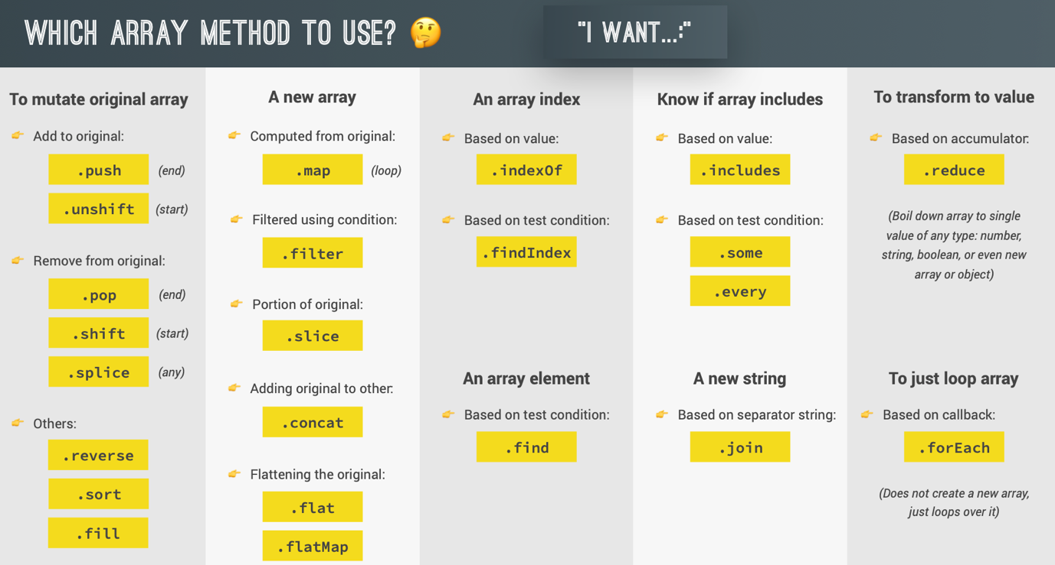

**Object Oriented Programming (OOP):**

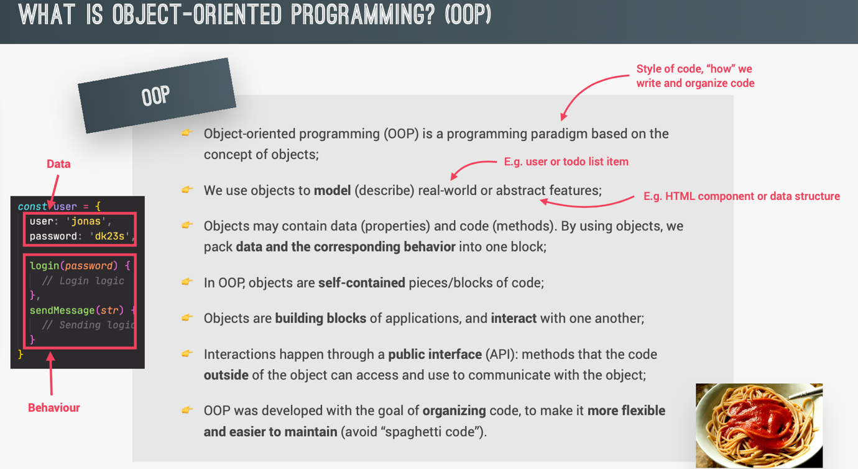

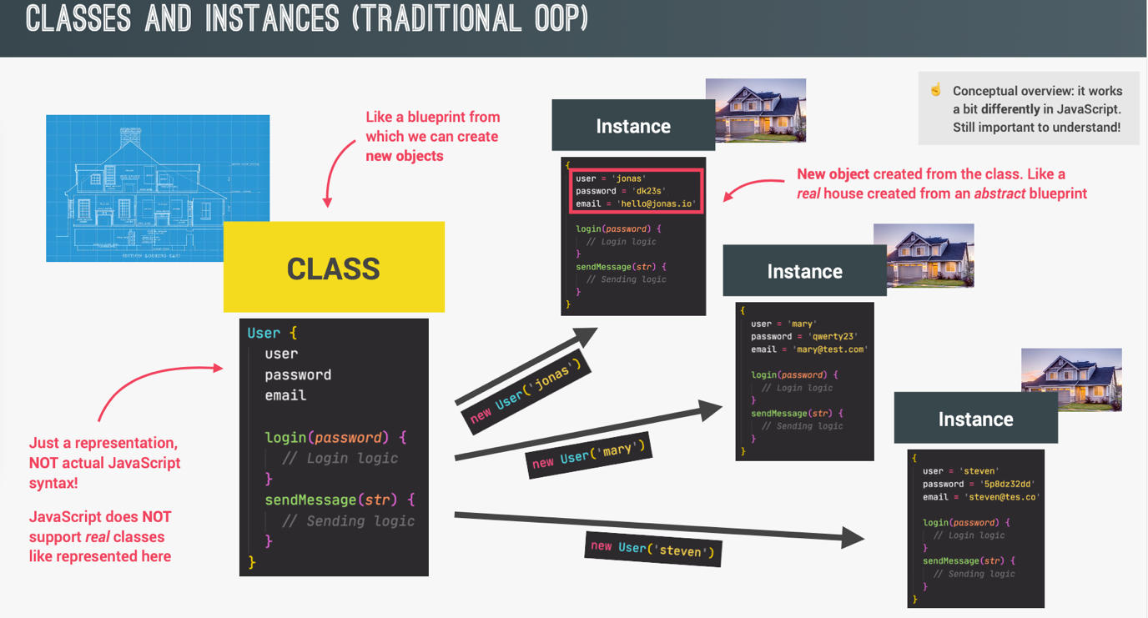

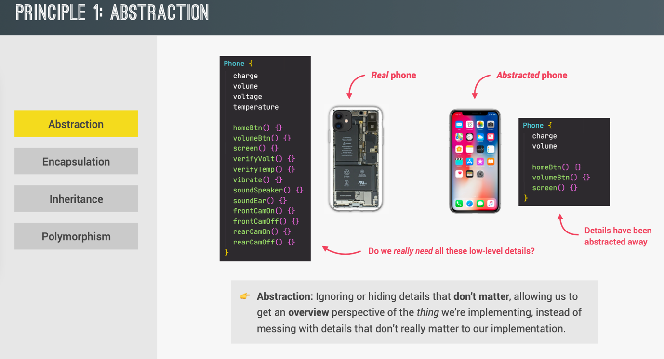

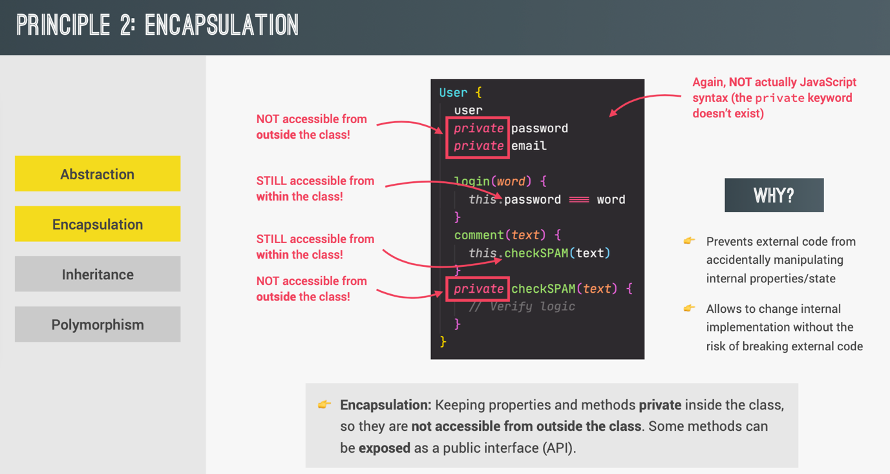

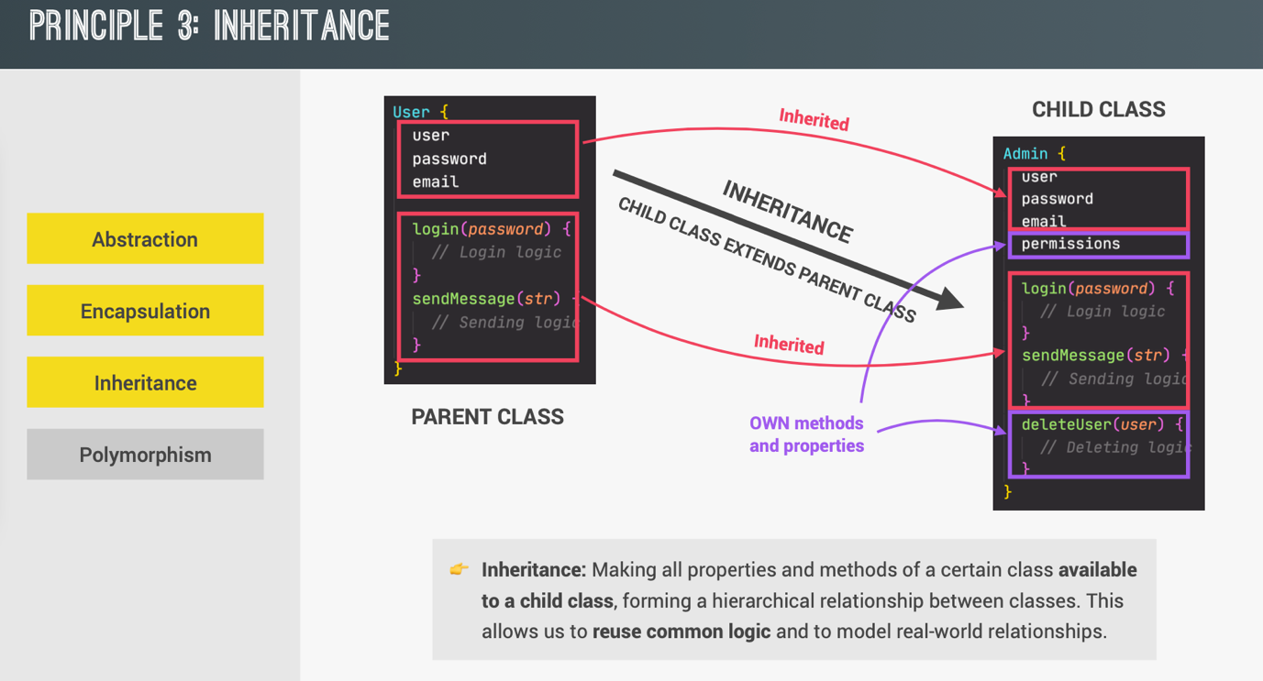

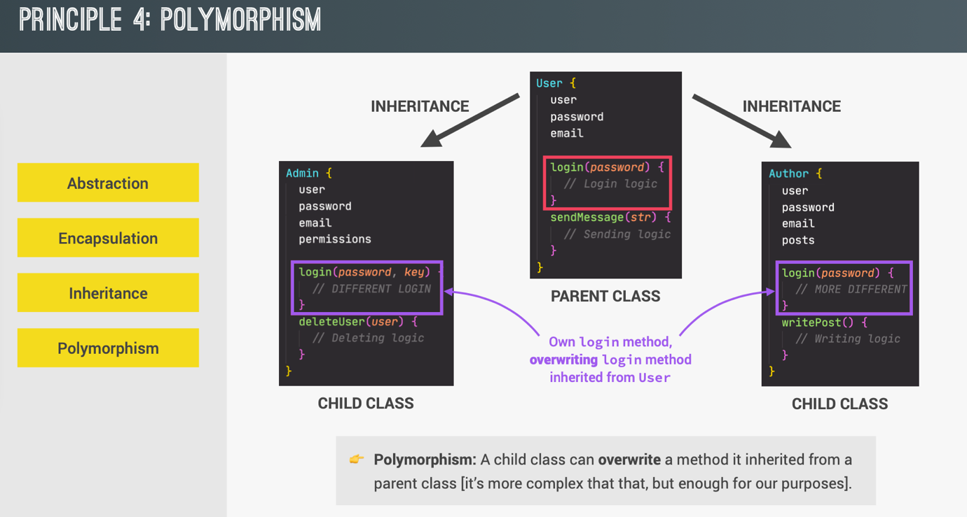

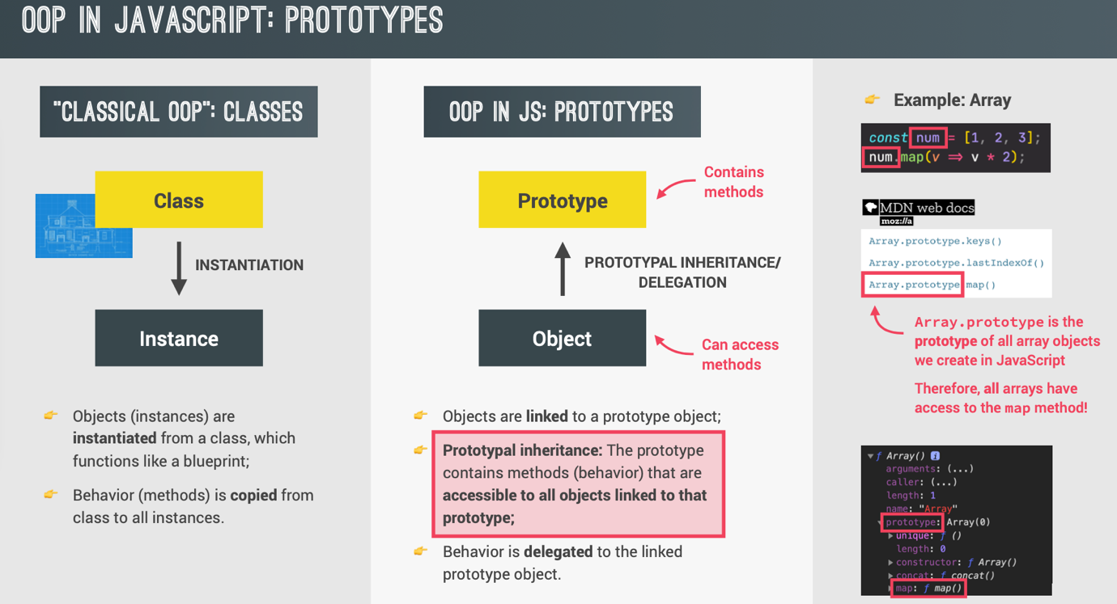

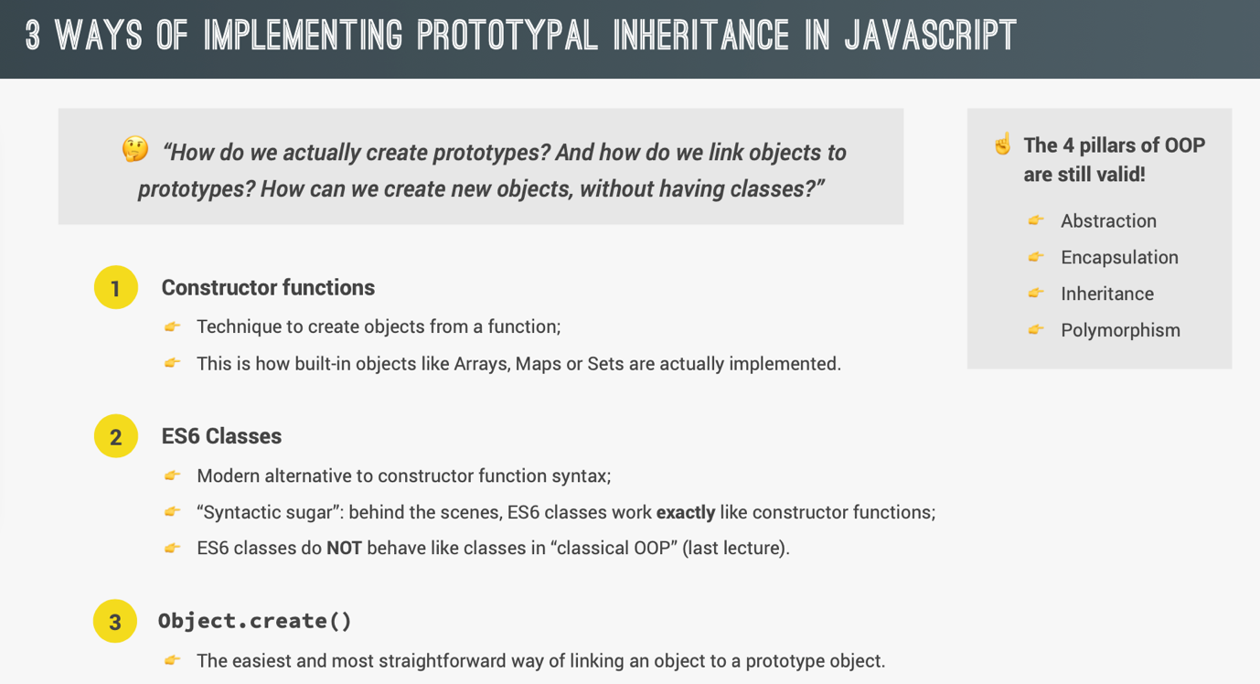

**Constructor function and the new operator:**

/**Constructor function */

const Person = function(firstName, birthYear) {

//Instance properties

this.firstName = firstName;

this.birthYear = birthyear;

//Never do this; Bad practice to define function in a constructor function, since it will creates copies. If we have created 100 instances of Person, then there will be 100 copies of the function calcAge.

//this.calcAge = function () {

// console.log(2037 – this.birthYear);

//};

};

/**Creating instance of Person. */

const jonas = new Person(‘Jonas’, 1991);

console.log(jonas instanceof Person); //true

//Important steps that happen when instance is created:

//1. New empty object {} is created.

//2. Function is called and ‘this’ is set to newly created object {}.

//3. Newly created object {} is linked to prototype. Sets the __proto__ property on the object to the prototype property of the constructor function

//4. Function automatically returns

**Prototypes:**

Each and every function in JavaScript automatically has a property called prototype. Constructor function also has that. Every object that is created by a certain constructor function will have access to the prototype property of the constructor function. So we can add functions or other properties to this prototype property of constructor function, which we want to be common between all the instances.

const Person = function (firstName, birthYear) {

this.firstName = firstName;

this.birthYear = birthYear;

}

console.log(Person.prototype); //It contains constructor and __proto__ property of Object.

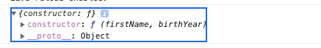

/**Prototypes: Adding methods. */

Person.prototype.calcAge = function () {

console.log(2037 – this.birthYear);

}

console.log(Person.prototype); //It contains calcAge(), constructor and __proto__ property of Object.

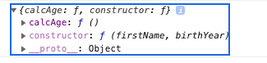

const jonas = new Person (‘Jonas’, 1991);

console.log(jonas); //jonas.__proto__ === Person.prototype

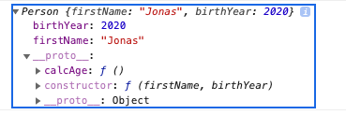

console.log(jonas.calcAge()); //46; it works!!

console.log(Jonas.__proto__ === Person.prototype); //true

console.log(Person.prototype.isPrototypeOf(jonas)); //true

console.log(Person.prototype.isPrototypeOf(Person)); //false; only it is the prototype for the instances created from it and not itself.

/**Prototypes: Adding properties */

Person.prototype.species = ‘Homo Sapiens’;

console.log(jonas.species); //Homo Sapiens

/**Properties present in __proto__ property of the instance are not their own. We can check using hasOwnProperty method. */

console.log(jonas.hasOwnProperty(‘firstName’)); //true

console.log(jonas.hasOwnProperty(‘species)); //false

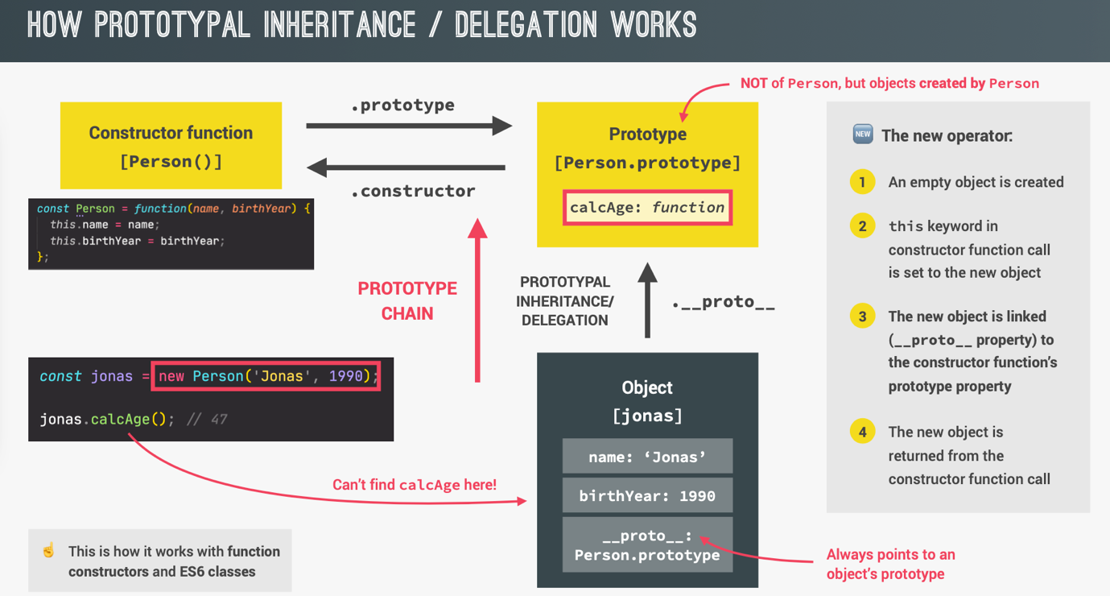

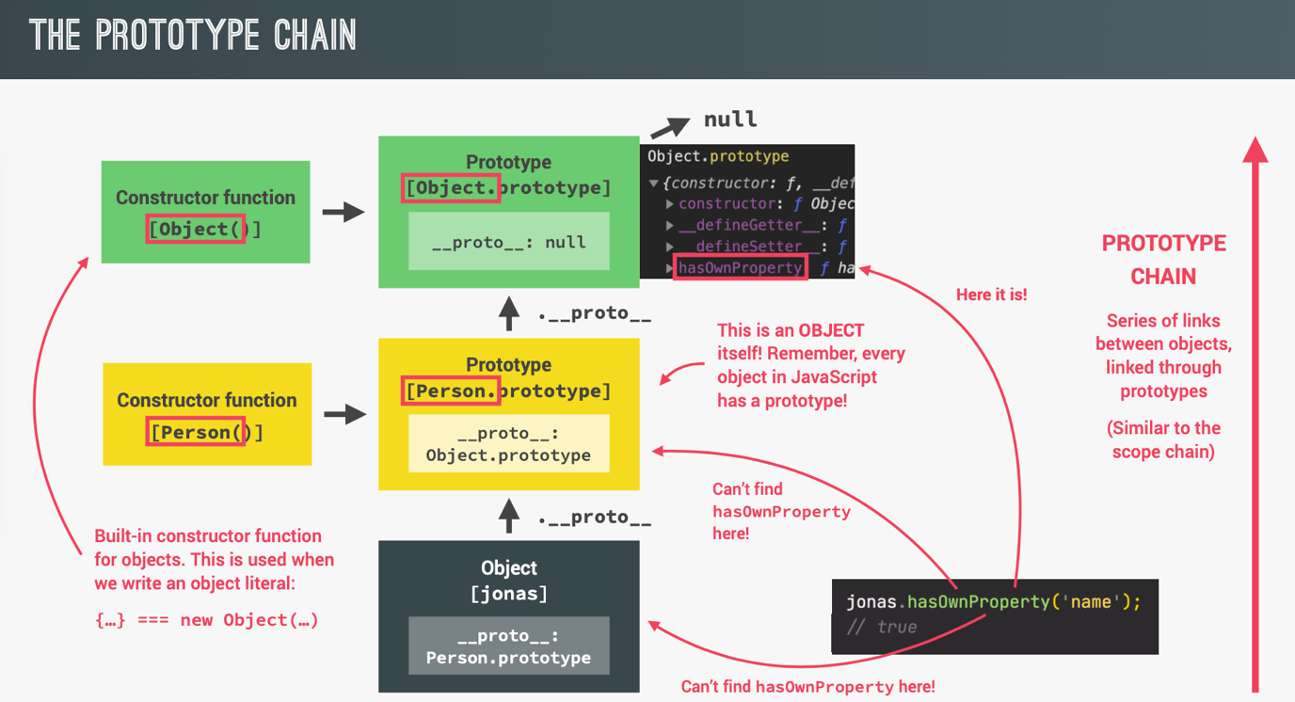

console.log(jonas.__proto__); // Person.prototype

console.log(jonas.__proto__.__proto__); //Object.prototype; It is at the top of the prototype chain

console.log(jonas.__proto__.__proto__.__proto__); //null

**Prototypal Inheritance on Built-in Objects:**

const arr = [1, 2, 3, 4, 2, 3, 5] // new Array === []; both methods of creating the array are the same

console.log(arr.__proto__); //Array.prototype

console.log(arr.__proto__.__proto__); //Object.prototype

//We can extend the prototype of a built-in object; but it is not a good idea. So avoid doing this. Here we are creating a new method to find unique values in array.

//Array.prototype.unique = function () {

// return [...new Set(this)];

//}

//console.log(arr.unique()); //1, 2, 3, 4, 5

**ES6 Classes:**

//Way1: Class Expression

const Person = class {

}

//Way2: Class Declaration

class Person {

constructor(firstName, birthYear) {

this.firstName = firstName;

this.birthYear = birthyear;

}

/**Methods defined outside the constructor will be added to the prototype property of the class. Similar to what we have done in previous topics. But in classes it is done automatically and we don’t have to explicitly assign a function to the prototype property. */

calcAge() {

console.log(2037 – this.birthYear);

}

}

const jessica = new Person(‘Jessica’, 1996);

console.log(jessica);

jessica.calcAge(); //41

console.log(jessica.__proto__ === Person.prototype); //true

//Important points:

//1. Classes are NOT hoisted.

//2. Classes are first class citizens.

//3. Classes are executed in strict mode.

**Setters and Getters:**

/**Example using object */

const account = {

owner: ‘Jonas’,

movements: [200, 530, 120, 300],

/**Getter: Normal function but pre-appended with keyword get. */

get latest() {

return this.movement.slice(-1).pop();

}

/**Setter: Normal function but pre-appended with keyword get. */

set latest(movement) {

this.movement.push(movement);

}

}

/**Using it just like a normal property and not like a function call. */

//Getter

console.log(account.latest); //300

//Setter

account.latest = 50;

console.log(account.latest); //[200, 530, 120, 300, 50]

/**Example using class */

class Person {

constructor(fullName, birthYear) {

this.fullName = fullName;

this.birthYear = birthyear;

}

calcAge() {

console.log(2037 – this.birthYear);

}

/**Setting a property that already exists.

So in the constructor **this.fullName** will actually call the setter function below. So there will be a conflict, which will create infinite loop. To avoid this we are not using the same variable **fullName** but we created another variable **_fullName**. */

set fullName(name) {

if (name.includes(‘ ’)) {

/**Here we have created another property _fullName and assigned it with name. So fullName property doesn’t really exist. It is _fullName now. So we need a getter function also, which will return us _fullName when we want fullName property of object. */

this._fullName = name;

}

else {

alert(`${name} is not a full name!`);

}

}

get fullName() {

return this._fullName;

}

}

const jessica = new Person(‘Jessica Davis’, 1996);

**Static methods:**

/**Example using constructor function */

const Person = function (firstName, birthYear) {

//Instance properties

this.firstName = firstName;

this.birthYear = birthyear;

}

//Static method

Person.hey = function () {

console.log(‘Hey there!’);

}

const jonas = new Person(‘Jonas’, 1991);

jonas.calcAge(); //41

jonas.hey(); //Error; since it is not in the prototype of jonas object.

Person.hey(); //Hey there!

/**Example using class */

class Person {

constructor(firstName, birthYear) {

this.firstName = firstName;

this.birthYear = birthyear;

}

//Instance method

calcAge() {

console.log(2037 – this.birthYear);

}

//Static method

static hey () {

console.log(‘Hey there!’);

}

}

const jonas = new Person(‘Jonas’, 1991);

jonas.hey(); //Error; since it is not in the prototype of jonas object.

Person.hey(); //Hey there!

**Object.create:**

Classes automatically set the prototype of instances to the constructor’s prototype property. We do not have to do it. But with using Object.create we can set the prototypes of objects manually. Using Object.create is the least used way of implementing prototypal inheritance.

const PersonProto = {

calcAge() {

console.log(2037 – this.birthYear);

}

};

const steven = Object.create(PersonProto); /**Empty object with steven.__proto__ === PersonProto */

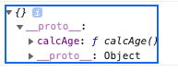

/**Now creating the properties. */

steven.name = ‘Steven’;

steven.birthYear = 2002;

steven.calcAge(); //35

console.log(steven.__proto__ === PersonProto); true

const PersonProto = {

calcAge() {

console.log(2037 – this.birthYear);

},

/**Better way of initializing, than the previous example. */

init(firstName, birthYear) {

this.firstName = firstName;

this.birthYear = birthYear;

}

};

const sarah = Object.create(PersonProto);

/**Better way of initializing than the previous example. */

sarah.init(‘Sarah’, 1979);

sarah.calcAge(); //58

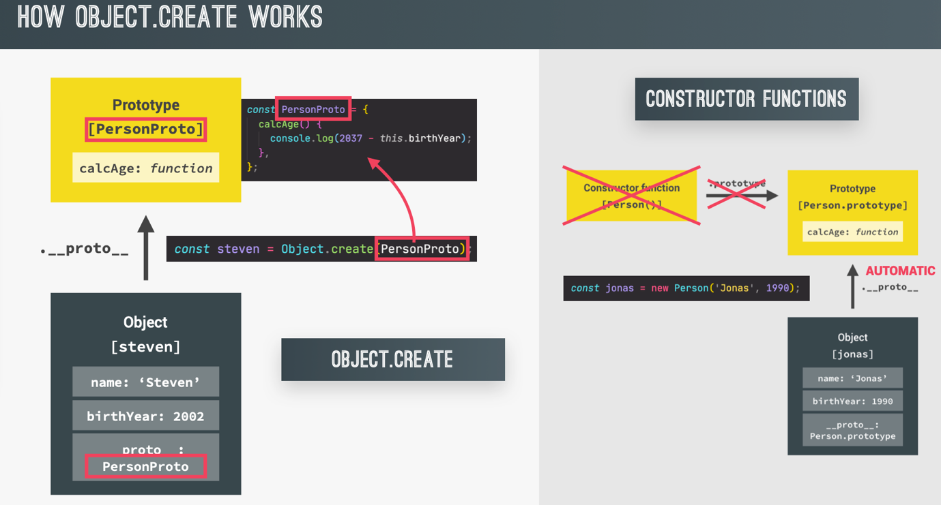

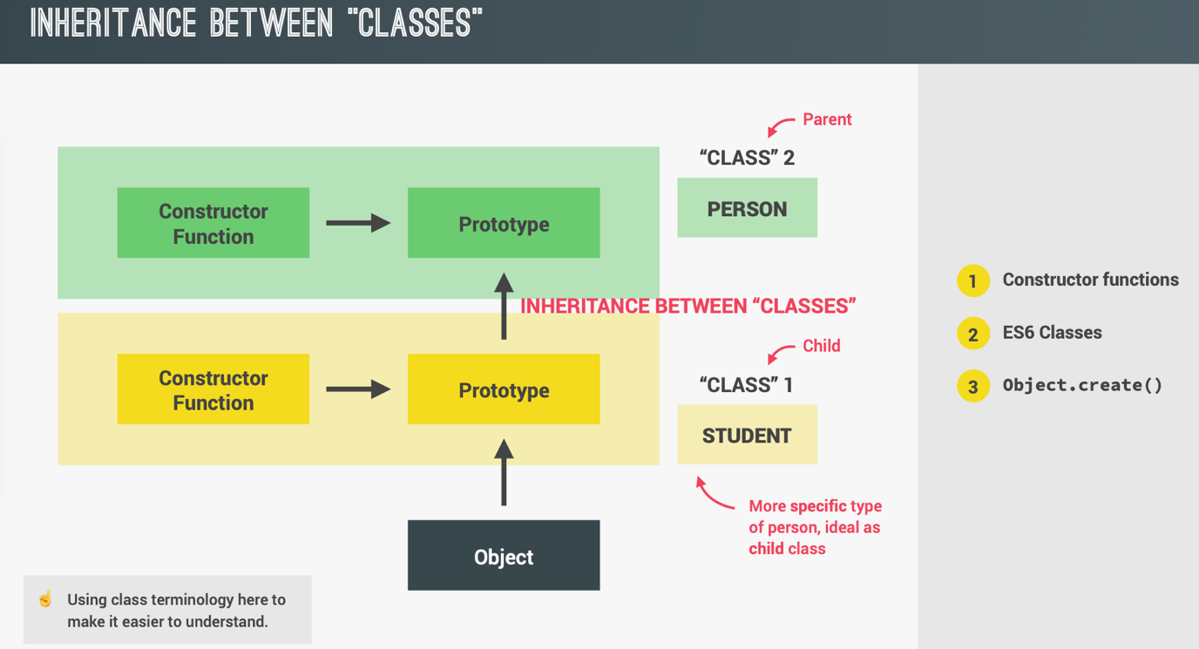

**Inheritance between classes: Constructor functions**

/**Parent */

const Person = function (firstName, birthYear) {

this.firstName = firstName;

this.birthYear = birthYear;

};

Person.prototype.calcAge = function () {

console.log(2037 – this.birthYear);

};

/**Child */

const Student = function (firstName, birthyear, course) {

/**Repeated code. Can be avoided by using Person constructor function */

//this.firstName = firstName;

//this.birthYear = birthYear;

/**Better way: Using Person constructor function and setting the this keyword using **call** method. */

Person.call(this, firstName, birthYear);

this.course = course;

}

/**Creating connection between child and parent manually.

This will create empty object with __proto__ set to Person.prototype property. This we are then assigning to prototype property of Student. This is the correct way, since we have local methods of Child(i.e introduce()) alongwith inherited methods from Parent in the __proto__property. */

Student.prototype = Object.create(Person.prototype);

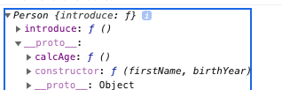

/**If we do Student.prototype = Person.prototype . This will not be inheriting. This will simply copy methods from Person.prototype to Student.prototype. Even this will work. But is not what we want. */

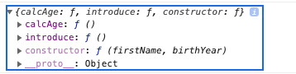

/**Now we can add methods to the prototype now. */

Student.prototype.introduce = function () {

console.log(`My name is ${this.firstName} and I study ${this.course}`);

}

const mike = new Student(‘Mike’, 2020, ‘Computer Science’);

mike.introduce(); // My name is Mike and I study Computer Science

mike.calcAge(); // 17

console.log(mike instanceof Student); //true

console.log(mike instanceof Person); //true

Student.prototype.constructor = Student;

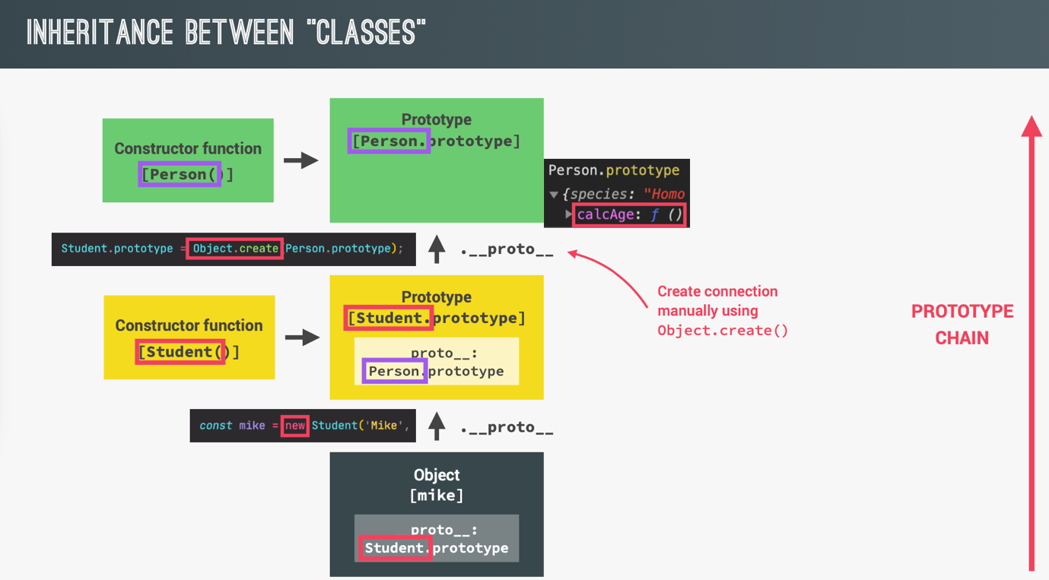

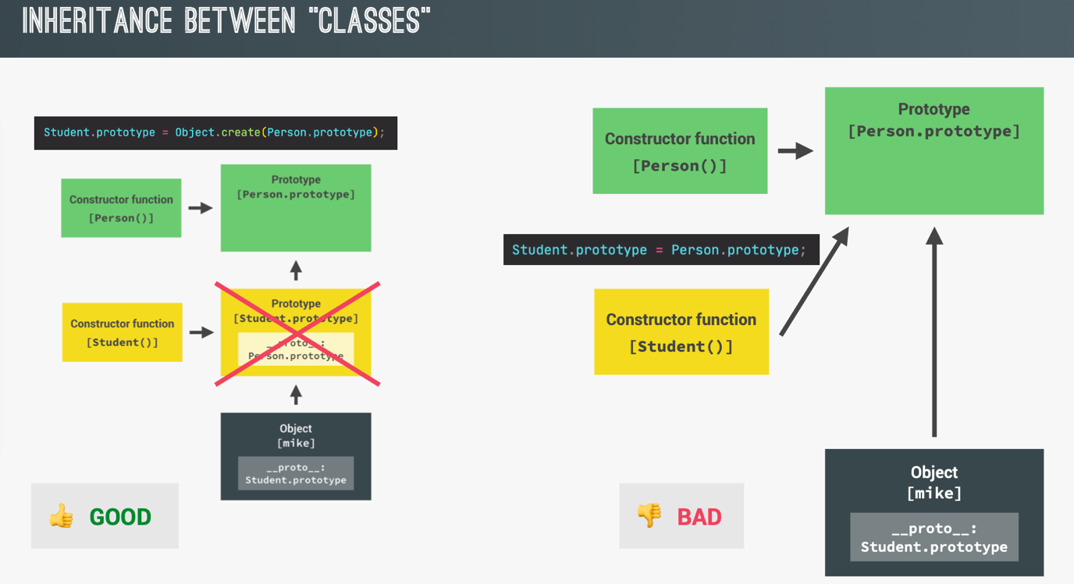

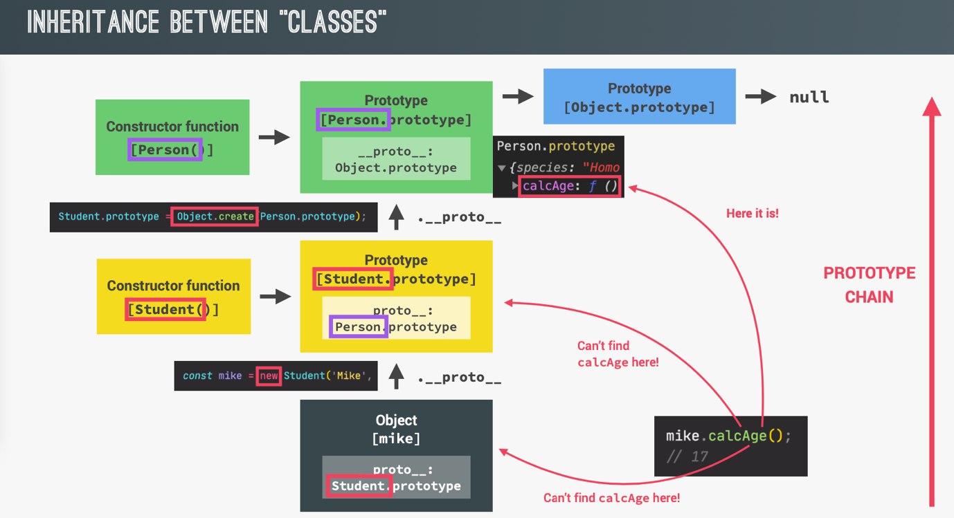

**Inheritance between classes: ES6 Classes**

class Person {

constructor(firstName, birthYear) {

this.firstName = firstName;

this.birthYear = birthyear;

}

//Instance method

calcAge() {

console.log(2037 – this.birthYear);

}

}

class Student extends Person {

constructor(firstName, birthYear, course) {

//Calling parent class constructor which will set the ‘this’. Always needs to happen first; Otherwise we cannot access this keyword.

super(firstName, birthYear, course);

this.course = course;

}

introduce() {

console.log(`My name is ${this.firstName} and I study ${this.course}`);

}

}

const martha = new Student (‘Martha’, 2012, ‘Computer Science’);

martha.introduce(); //My name is Martha and I study Computer Science

martha.calcAge(); //25

**Inheritance between classes: Object.create**

const PersonProto = {

calcAge() {

console.log(2037 – this.birthYear);

},

init(firstName, birthYear) {

this.firstName = firstName;

this.birthYear = birthYear;

}

};

const StudentProto = Object.create(PersonProto);

StudentProto.init = function (firstName, birthYear, course) {

PersonProto.init.call(this, firstName, birthYear);

this.course = course;

};

StudentProto.introduce = function () {

console.log(`My name is ${this.firstName} and I study ${this.course}`);

};

const steven = Object.create(StudentProto);

steven.init(‘Steven’, 1992, ‘CSE’);

steven.introduce();

steven.calcAge();

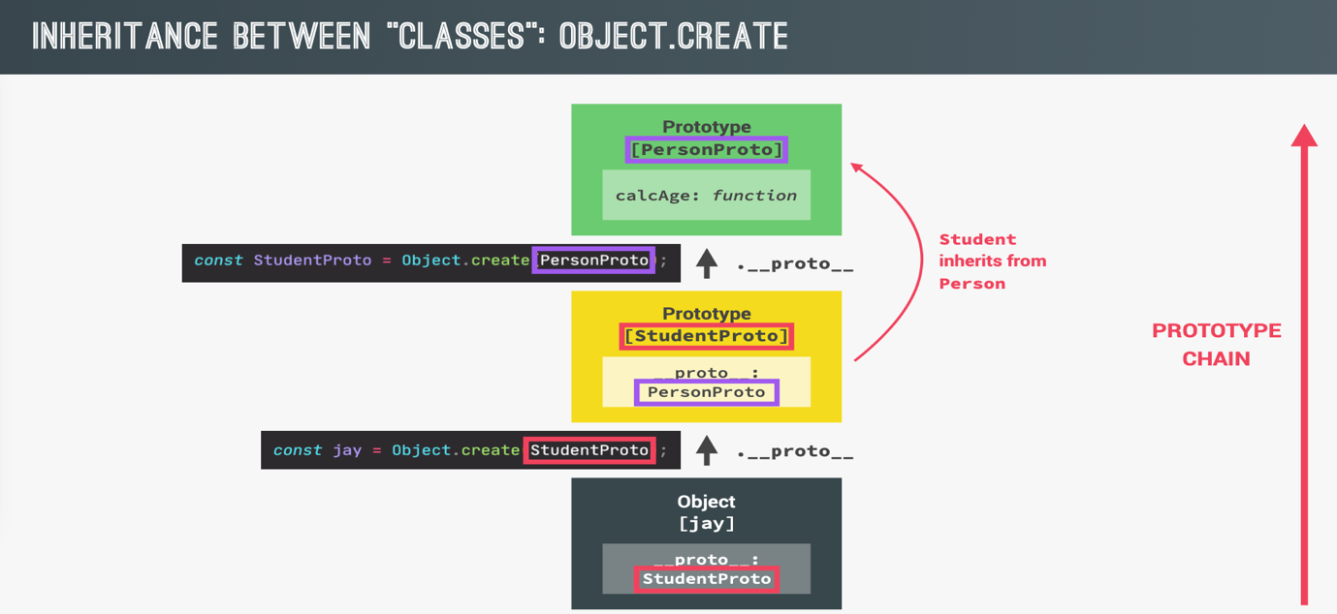

**Another Class example: Need for encapsulation**

class Account {

constructor(owner, currency, pin) {

this.owner = owner;

this.currency = currency;

this.pin = pin;

this.movements = [];

}

//Public Interface

deposit(val) {

this.movements.push(val);

}

withdraw(val) {

this.deposit(-val);

}

approveLoan(val) {

return true;

}

requestLoan(val) {

if(this.approveLoan(val)) {

this.deposit(val);

console.log(‘Loan Approved!’);

}

}

}

const acc1 = new Account(‘Jonas’, ‘EUR’, 1111);

/**Not recommended to manipulate the properties directly. */

acc1.movements.push(250);

acc1.movements.push(-140);

/**Better way: Expose the methods to public interface. API. */

acc1.deposit(250);

acc1.withdraw(140);

acc1.requestLoan(1000);

/**Nothing stops a user doing this. Some methods and properties should be encapsulated to prevent accidental data manipulation. */

acc1.pin = 1234;

acc1.approveLoan(1000);

**Encapsulation: Protected properties and methods**

Some properties and methods must be kept private inside the class, so that they are not accessible from outside the class and this prevents accidental manipulation of the data.

While some of the methods are exposed as a public interface (API).

/**Faking the encapsulation using the developers convention. Here rules must be followed by the developers. */

class Account {

constructor(owner, currency, pin) {

this.owner = owner;

this.currency = currency;

/**Protected property: Convention to place pre-append underscore to the property name. By this way the developers know that the property is not intended to be modified outside the class. */

this._pin = pin;

this._movements = [];

}

//Public Interface

deposit(val) {

this._movements.push(val);

}

withdraw(val) {

this.deposit(-val);

}

/**Protected method. */

_approveLoan(val) {

return true;

}

requestLoan(val) {

if(this._approveLoan(val)) {

this.deposit(val);

console.log(‘Loan Approved!’);

}

}

}

const acc1 = new Account(‘Jonas’, ‘EUR’, 1111);

Remaining Encapsulation...Not required...

**Asynchronous JavaScript:**

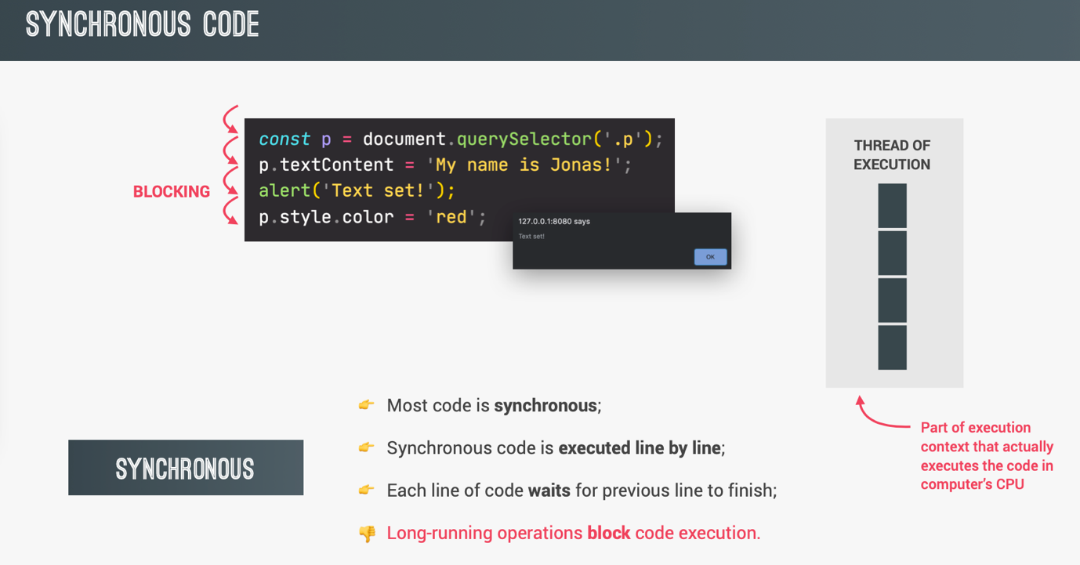

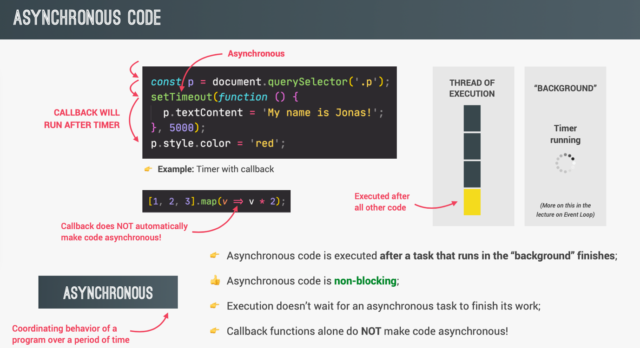

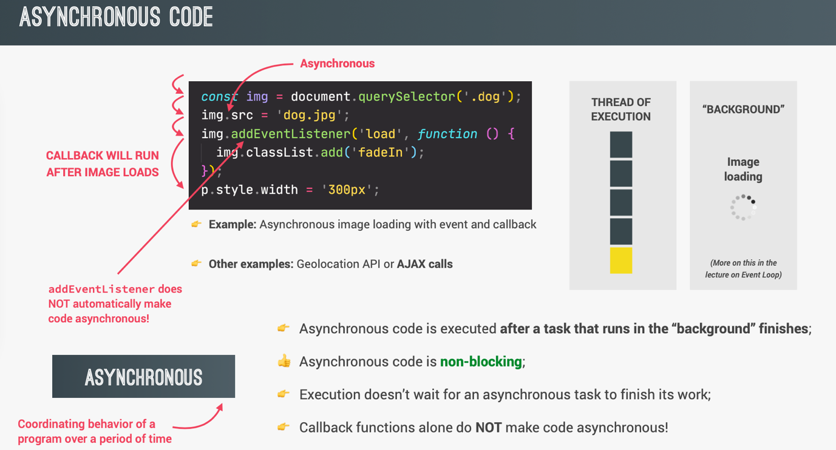

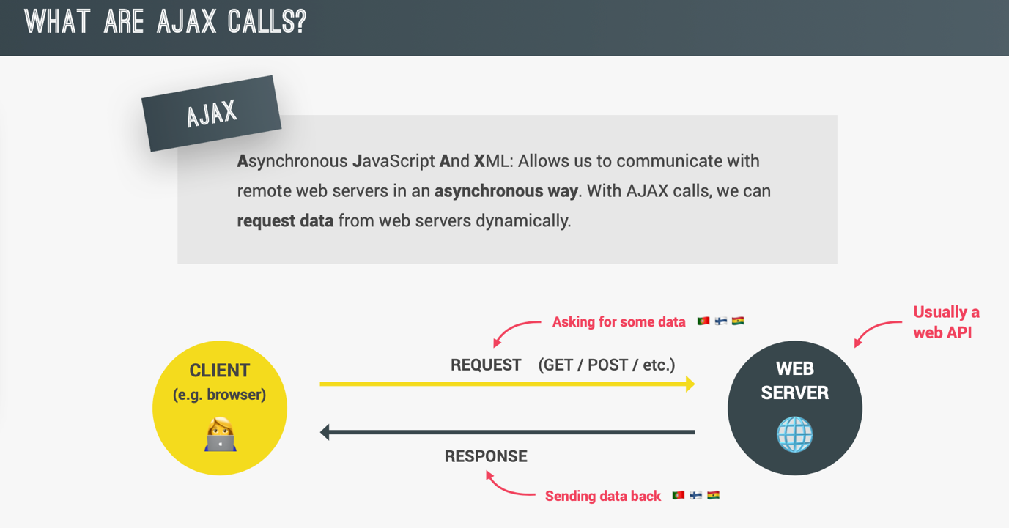

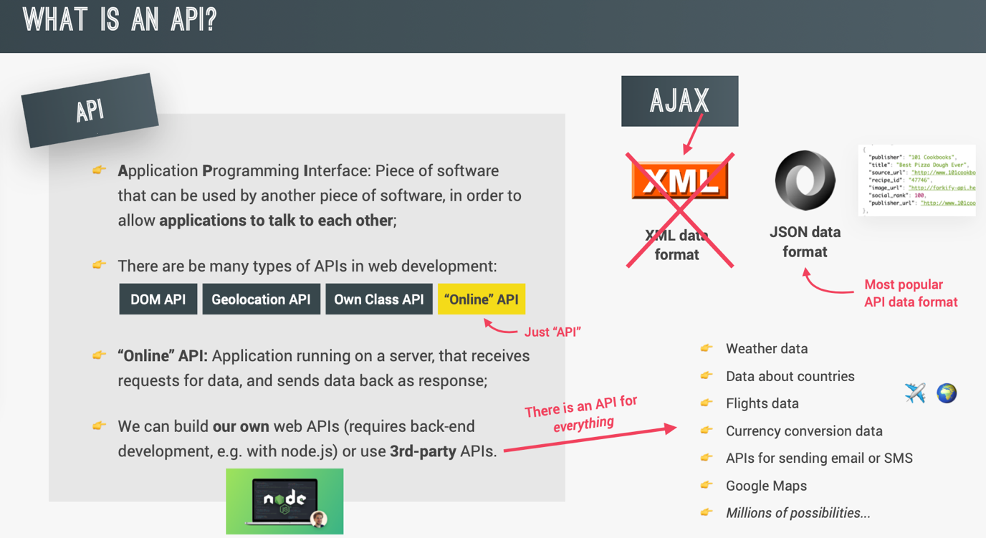

**Callback Hell:**

When we have a lot of nested callbacks in order to execute asynchronous tasks in sequence. It makes code hard to understand and difficult to reason about.

setTimeout(() => {

console.log(‘1 Second passed’);

setTimeout(() => {

console.log(‘2 Second passed’);

setTimeout(() => {

console.log(‘3 Second passed’);

setTimeout(() => {

console.log(‘4 Second passed’);

}, 1000);

}, 1000);

}, 1000);

}, 1000);

//1 Second passed

//2 Second passed

//3 Second passed

//4 Second passed

**Promise and the Fetch API:**

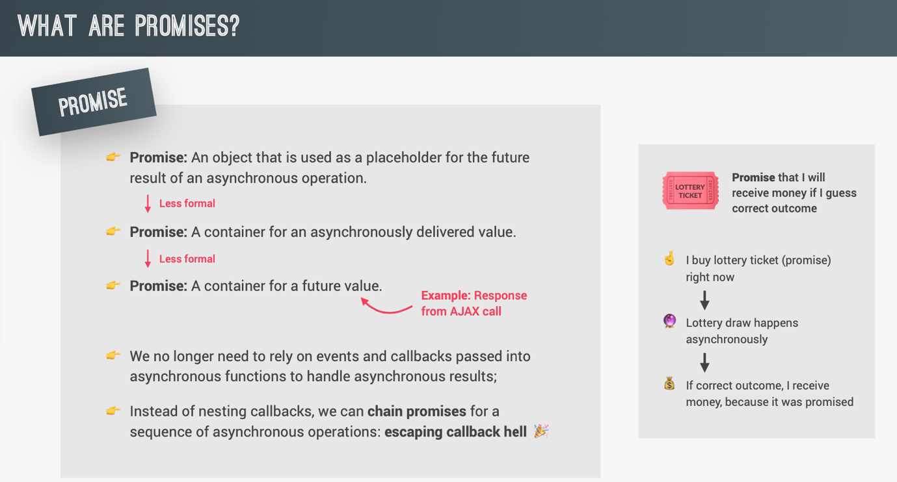

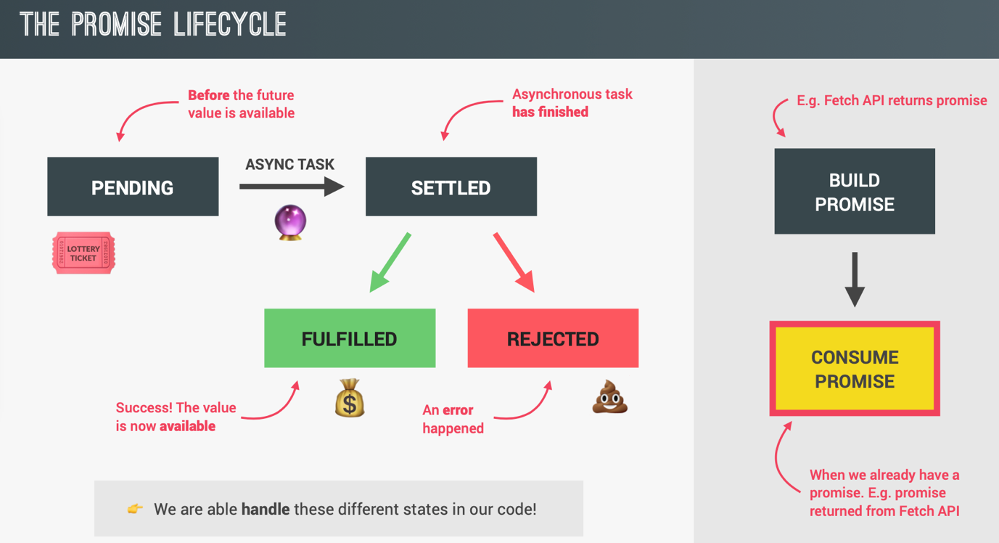

**Consuming Promises:**

const getCountryData = function(country) {

fetch(‘https://restcountries.eu/rest/v2/name/${country}’)

.then(function(response) {

//Handling fulfilled promise

console.log(response);

//returning a new promise, which can then be chained

return response.json();

})

.then(function(data) {

console.log(data);

//UI Method to render country in web page...

renderCountry(data[0]);

});

};

getCountryData(‘portugal’);

**Chaining Promises:**

const getCountryAndNeighbour = function(country) {

//Fetch data for country 1

fetch(‘https://restcountries.eu/rest/v2/name/${country}’)

.then(response => response.json())

.then(data => {

renderCounty(data[0]);

const neighbour = data[0].borders[0]

if (!neighbour) return;

//Fetch data for country 2

return fetch(‘https://restcountries.eu/rest/v2/name/${neighbour}’)

})

.then(response => response.json())

.then(data => renderCountry(data));

};

getCountryAndNeighbour(‘portugal’);

**Handling Rejected Promises:**

/**Way1: Passing second callback to the then method. */

const getCountryData = function(country) {

fetch(‘https://restcountries.eu/rest/v2/name/${country}’)

.then(function(response) {

//First callback: Handling fulfilled promise

console.log(response);

//returning a new promise, which can then be chained

return response.json();

}, function(err) {

//Second callback: Handling rejected promise

console.log(err);

})

.then(function(data) {

console.log(data);

//UI Method to render country in web page...

renderCountry(data[0]);

});

};

getCountryData(‘portugal’);

/**Way2: Using catch method to catch all errors at one place. Much better way. Both ways are same. Just using catch is a shorthand and looks better. */

const getCountryData = function(country) {

fetch(‘https://restcountries.eu/rest/v2/name/${country}’)

.then(function(response) {

console.log(response);

//returning a new promise, which can then be chained

return response.json();

})

.then(function(data) {

console.log(data);

//UI Method to render country in web page. Do not care

renderCountry(data[0]);

})

.catch(function(err) {

//Handling all errors here

console.log(err);

//Optional: Displaying custom error

console.error(`${err}💥💥💥`);

});

};

getCountryData(‘portugal’);

**Throwing Errors Manually:**

Sometimes we need to throw errors manually for specific cases. Like requesting the details for a country for which doesn’t exist. Here after the API call; **response.ok** will be false or the **status** will be 400. So further use of response object will create errors which will ultimately go to catch block and display some generic message. But we want to display the user that the country was not found, so we throw the error manually and set the error message. This will reject the promise immediately and it will then be ultimately catched by the catch block and our specific error will be displayed.

const getCountryAndNeighbour = function(country) {

//Fetch data for country 1

fetch(‘https://restcountries.eu/rest/v2/name/${country}’)

.then(response => {

//Throwing Error

if (!response.ok) {

throw new Error(`Country not found (${response.status})`);

}

return response.json();

})

.then(data => {

renderCounty(data[0]);

const neighbour = data[0].borders[0]

if (!neighbour) return;

//Fetch data for country 2

return fetch(‘https://restcountries.eu/rest/v2/name/${neighbour}’)

})

.then(response => {

//Throwing Error

if (!response.ok) {

throw new Error(`Country not found (${response.status})`);

}

return response.json();

})

.then(data => renderCountry(data))

.catch(err => {

console.error(`${err}💥💥💥`);

})

};

getCountryAndNeighbour(‘portugal’);

/**Removing duplicate code from above code to make it more readable. */

/**Helper function */

const getJSON = function (url, errorMsg = ‘Something went wrong’) {

fetch(url).then(response => {

if (!response.ok) {

throw new Error(`${errorMsg} (${response.status})`);

}

return response.json();

});

};

const getCountryData = function(country) {

//Fetch data for country 1

getJSON(`https://restcountries.eu/rest/v2/name/${country}`, ‘Country not found’)

.then(data => {

renderCounty(data[0]);

const neighbour = data[0].borders[0]

if (!neighbour) {

throw new Error(‘No neighbour found!’);

}

//Fetch data for country 2

return getJSON(`https://restcountries.eu/rest/v2/alpha/${neighbour}`, ‘Country not found’);

})

.then(data => renderCountry(data))

.catch(err => {

console.error(`${err}💥💥💥`);

})

};

getCountryData(‘portugal’);

**Asynchronous Behind the scenes: The Event Loop**

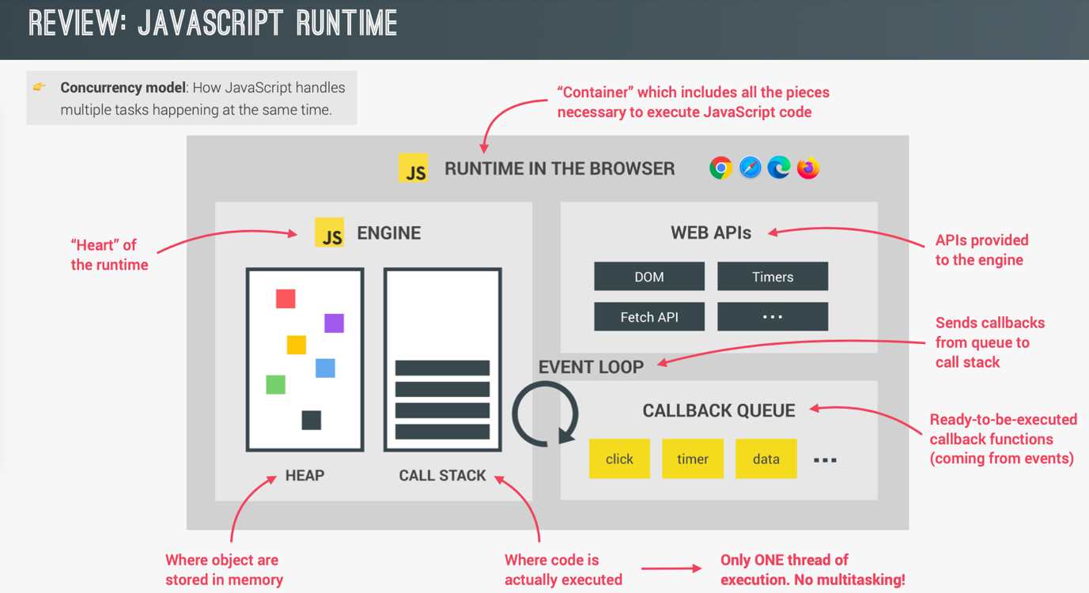

**Step1:** Execute code line by line.

**Step2:** If there is a callback, it will wait in the Web API container. In example here; image loader callback will wait.

**Step3:** Then we execute another piece of code. In example here; we fetch the data. Since it also has a callback promise. It will wait in Web API container. And we continue executing any other code if present.

**Step4:** If the event finishes. Like in this example; when the image loads, the image loader callback will be enqueued in the callback queue by the event loop. There could be another callbacks waiting for their turn for execution in the callback queue. The event loop checks that if the execution stack is empty(No tasks other than global execution context). If it is empty then it will pick the callback which is first in line and add it to the call stack to start its execution.

This way for example, even if we have a setTimeout for 5 seconds. Our callback is not guaranteed to run after exact 5 seconds. After 5 seconds it will be enqueued to the callback queue and there if there are any more callbacks; then it will wait for its turn. But definitely it will be executed after 5 seconds but not exactly after 5 seconds.

**Step5:** Promise callbacks takes priority on the regular callbacks and are enqueued in the MicroTasks queue. In example here; fetch promise callback will be enqueued to the MicroTasks queue.

So basically event loop picks up callbacks from Web API container and enqueues them in respective queues: MicroTasks queue(for all promise callbacks) and callback queue(for all regular callbacks)

It checks if the call stack is empty; if yes then it picks up items from MicroTasks queue and pushes them to call stack. If MicroTasks queue is empty; then it picks up an item from callback queue and pushes it to call stack.

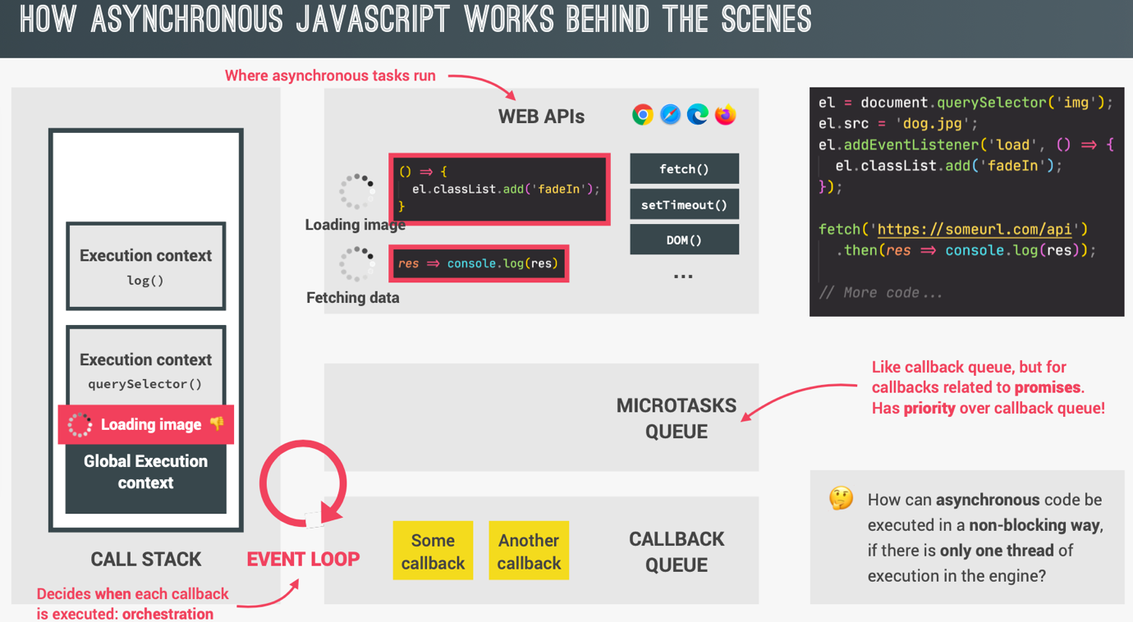

console.log(‘Test start’);

setTimeout(() => console.log(‘0 Second timer’), 0);

/**Creating a promise and resolving it immediately. */

Promise.resolve(‘Resolved promise 1’).then(res => console.log(res));

console.log(‘Test end’);

//Order of execution:

//Test start //Global execution context

//Test end //Global execution context

//Resolves promise 1 //Callback from MicroTasks Queue

//0 Second timer //Callback from Callback queue

**Building a Simple Promise:**

//Executor function is passed as argument to new Promise constructor syxtax.

const lotteryPromise = new Promise(function(resolve, reject) {

console.log(‘Lottery draw is happening 🔮’);

setTimeout(function() {

if (Math.random() >= 0.5) {

//Fulfill

resolve(‘You WIN 💰’);

}

else {

//Reject

reject(‘You lost your money 💩’);

}

}, 2000);

});

lotteryPromise

.then(res => console.log(res))

.catch(err => console.error(err));

//Example: callback based Asynchronous behaviour function.

setTimeout(() => {

console.log(‘1 Second passed’);

setTimeout(() => {

console.log(‘2 Second passed’);

setTimeout(() => {

console.log(‘3 Second passed’);

setTimeout(() => {

console.log(‘4 Second passed’);

}, 1000);

}, 1000);

}, 1000);

}, 1000);

//1 Second passed

//2 Second passed

//3 Second passed

//4 Second passed

//Promisifying Above Example:

const wait = function (seconds) {

return new Promise(function(resolve) {

setTimeout(resolve, seconds * 1000);

});

};

wait(1)

.then(() => {

console.log(‘1 Second passed’);

//Returning a promise; which we can chain later

return wait(1);

})

.then(() => {

console.log(‘2 Second passed’);

//Returning a promise; which we can chain later

return wait(1);

})

.then(() => {

console.log(‘3 Second passed’);

//Returning a promise; which we can chain later

return wait(1);

})

.then(() => {

console.log(‘4 Second passed’);

});

//1 Second passed

//2 Second passed

//3 Second passed

//4 Second passed

**Consuming Promises with Async/Await:**

Declare a function to be **async** to enable the asynchronous behaviour of the function. Asynchronous functions run in background without blocking the main thread of execution. **await** before a line waits for the promise to settle.

const whereAmI = async function(country) {

let url = `https://restcountries.eu/rest/v2/name/${country}`

//Both below ways are same, behind the scenes. Async/Await is just a syntactic sugar

//New way:

const res = await fetch(url);

console.log(res);

//Old way:

fetch(url)

.then(res => console.log(res));

}

whereAmI(‘portugal’);

**Error handling with try .... catch :**

In normal promise we used catch method to catch the errors. But in async functions we were not able to catch errors. To do so, we use try....catch block.